|  |
| --- |
| **PROJECT TITLE:CHATBOT DEPLOYMENT WITH IBM WATSON ASSISTANT** |
| **PHASE IV-DEVELOPMENT PART II** |

**STEP 1:I logged into my IBM cloud ,then I open my already created assistant pages**

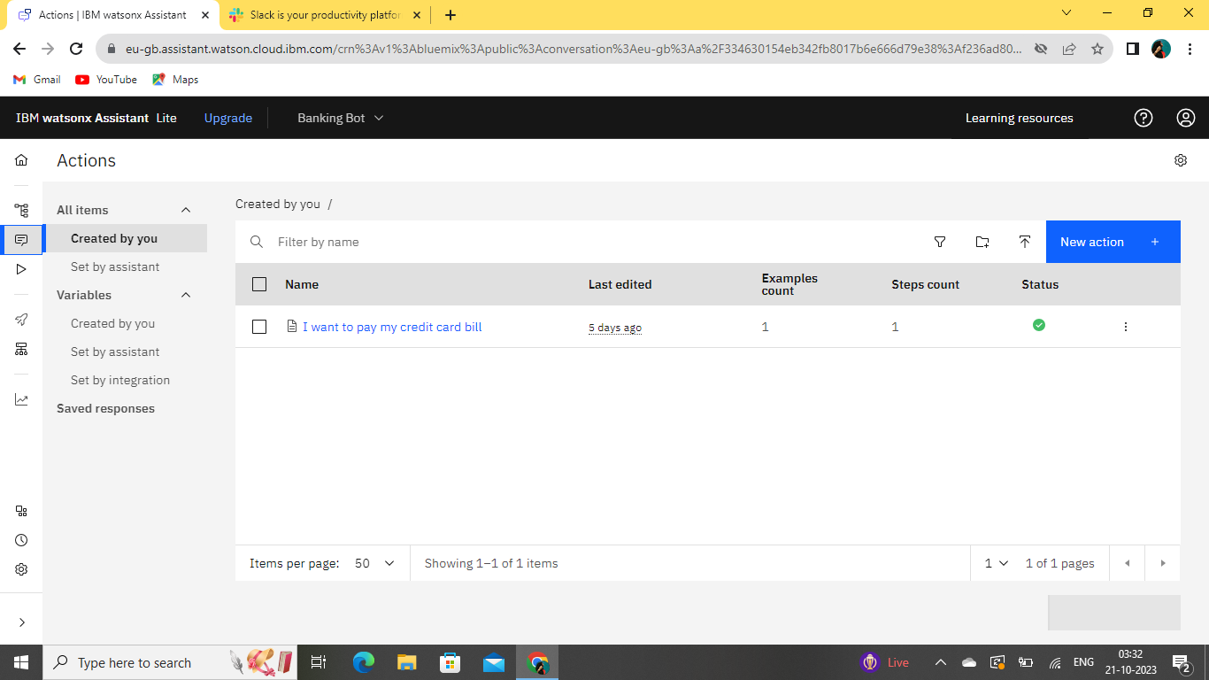

**Step 2: Here select the Integration option ,then select Slack and then Facebook meaasger**

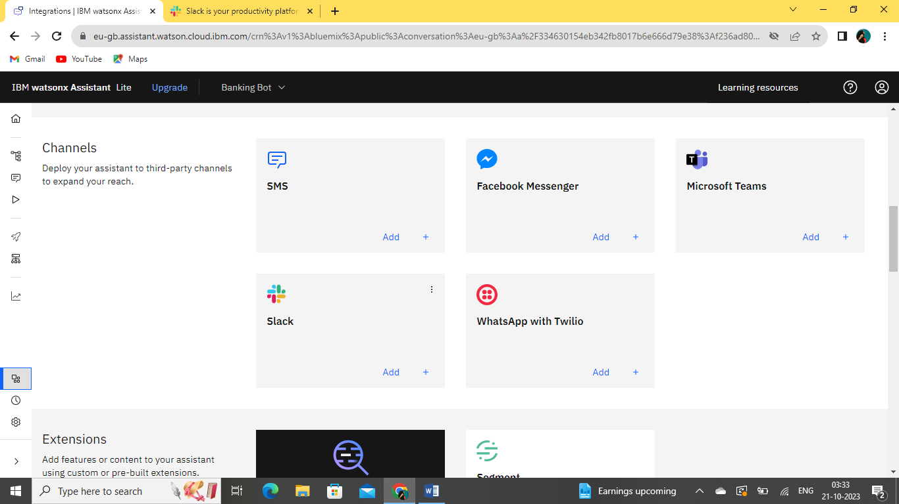

**Step 3: Create a slack account for my own named as FOOD DELIVERING**

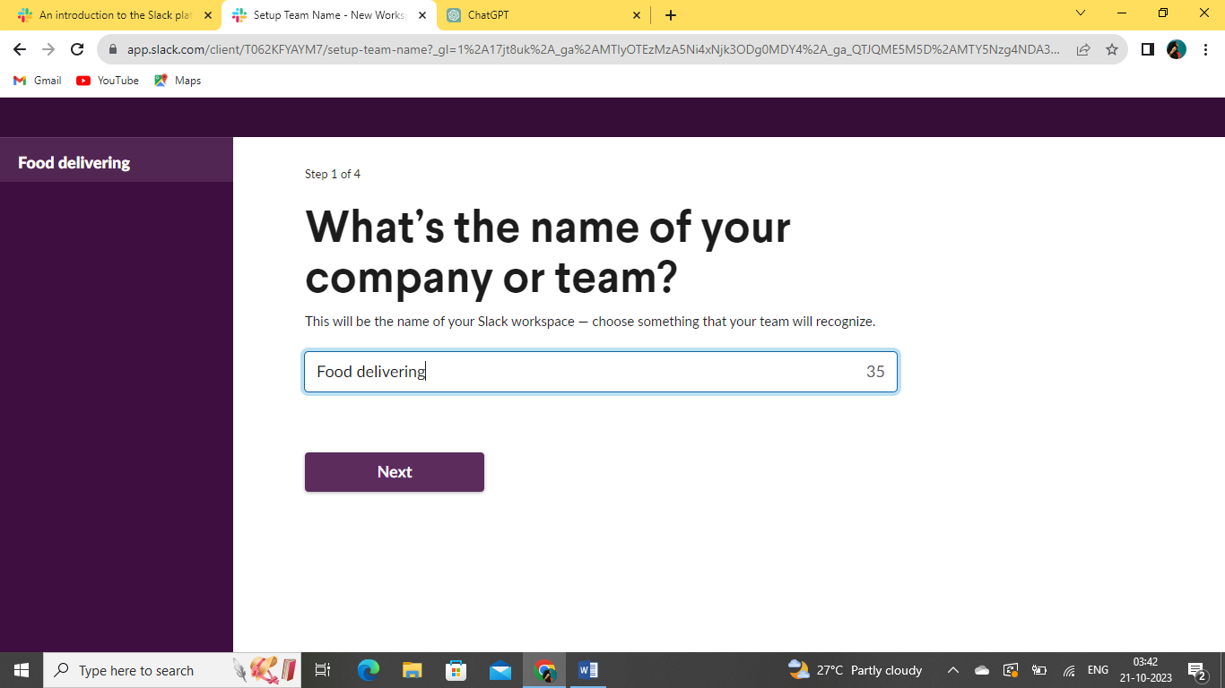

**STEP 4:Here I created a project**

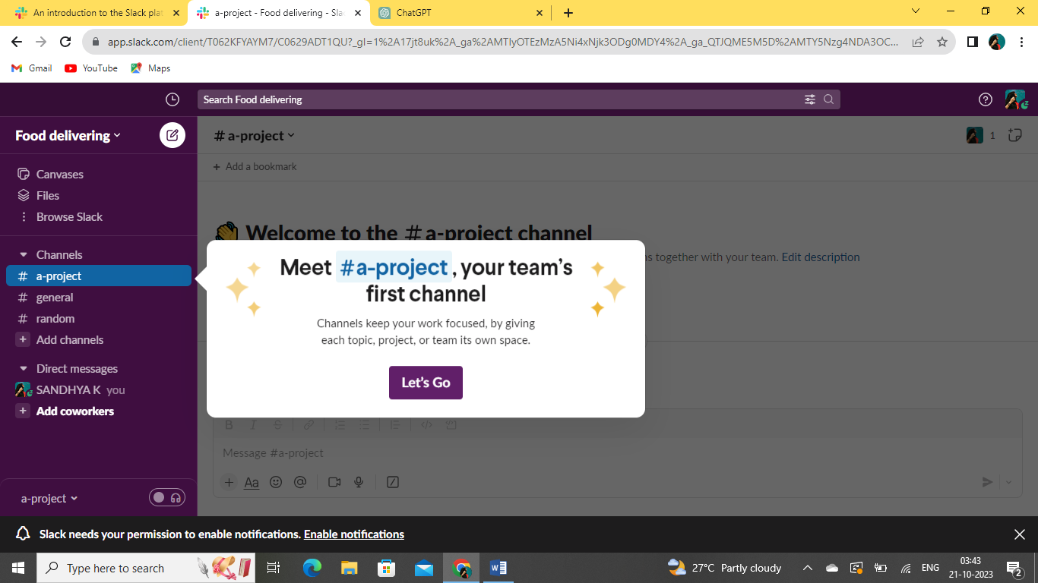

**Step 5: In that slack api ,now I created one app named as “CustomerServiceApp”**

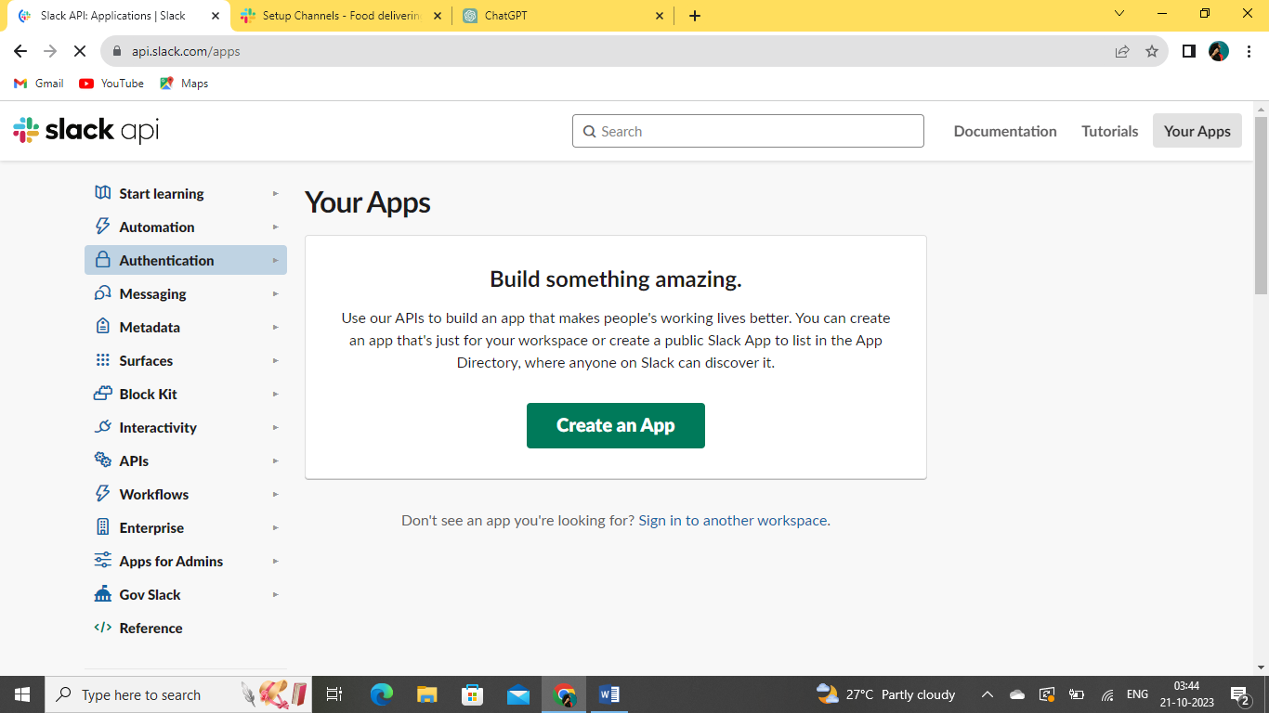

**6.Here, I Choose my workspace as “Food delivering”**

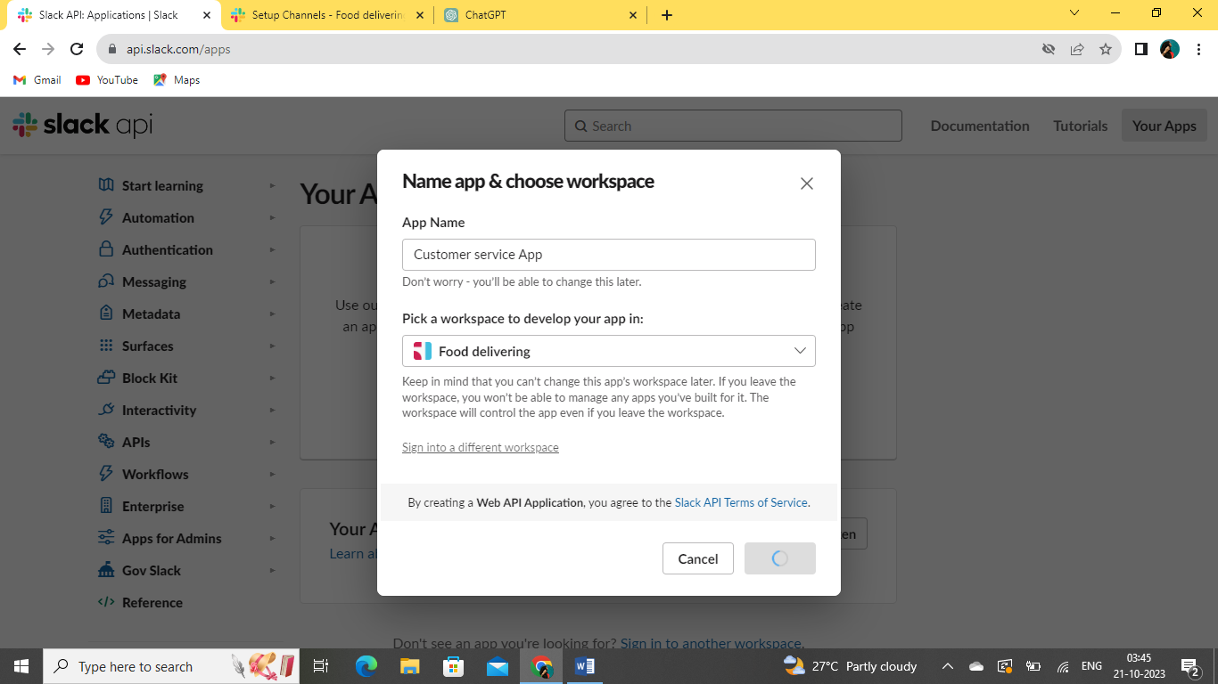

**7.Its shows my app is Configuring in code**

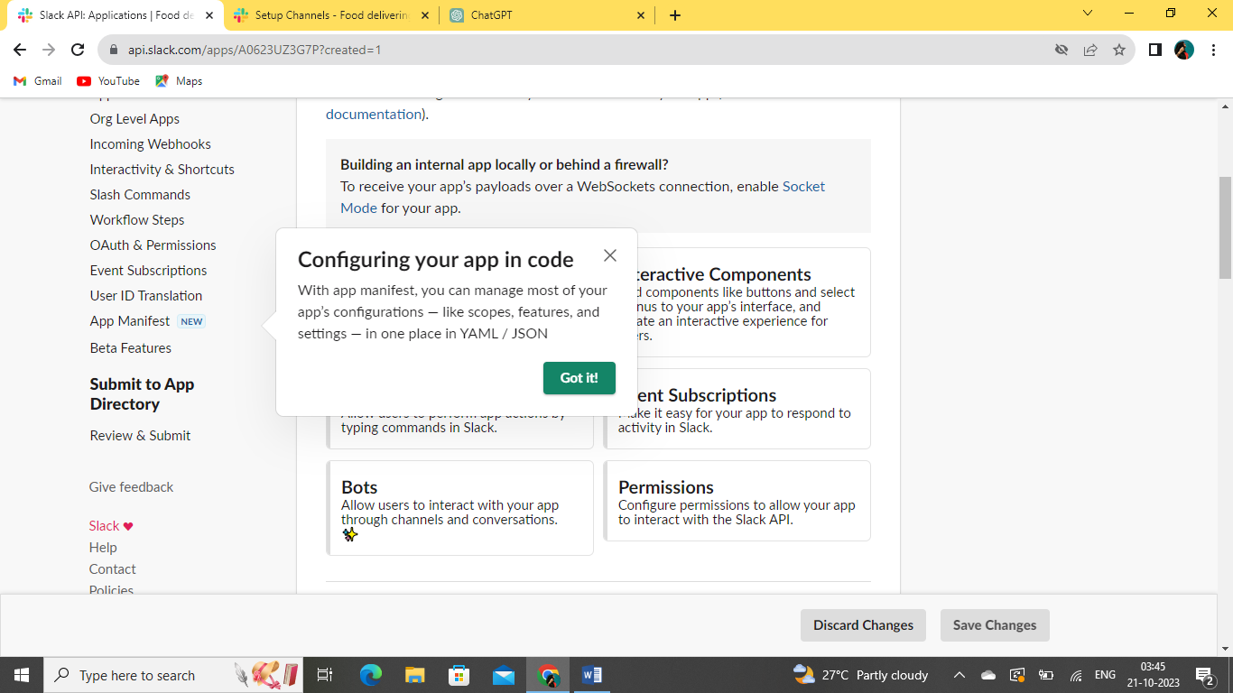

**8.Created app is shown here like CustomerServiceApp ,I click agree to further options.**

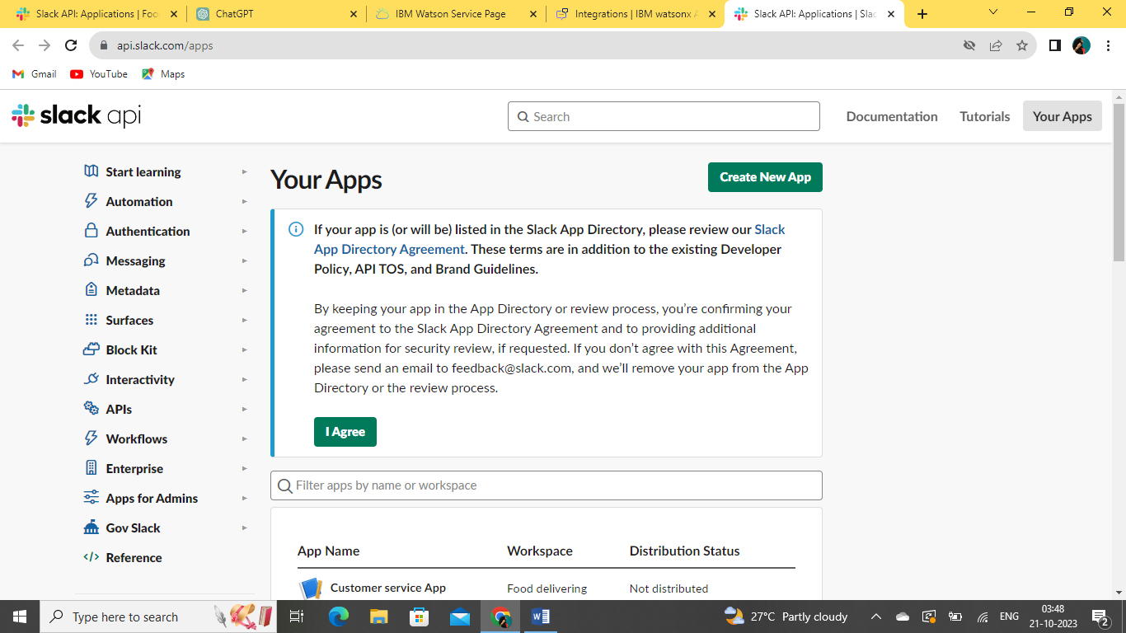

**9.Generate Tokens here**

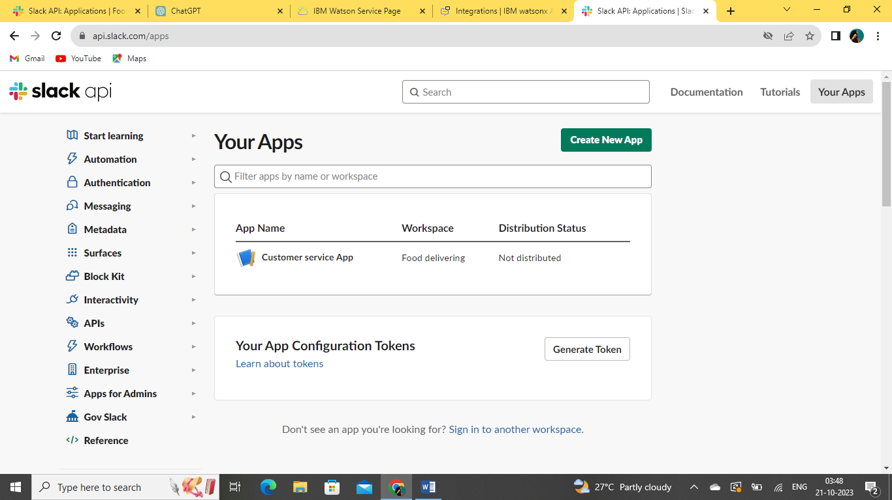

**10.Give all the credentials details here**

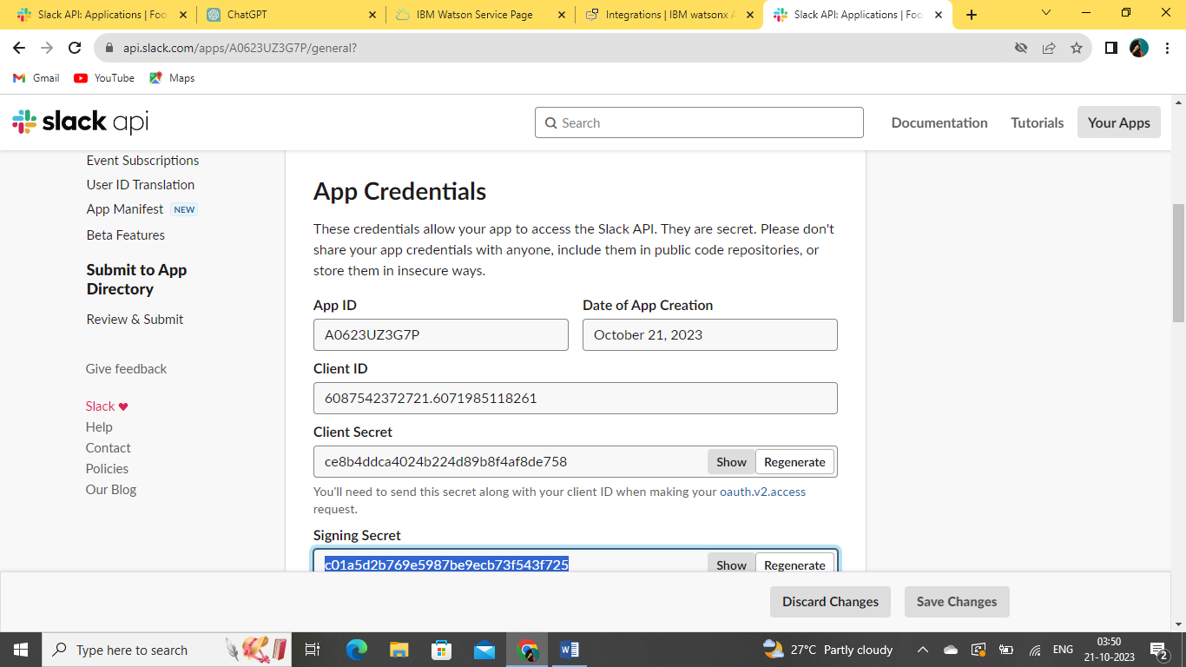

**11.Here is the list for all the further process..**

**Do one by one..**

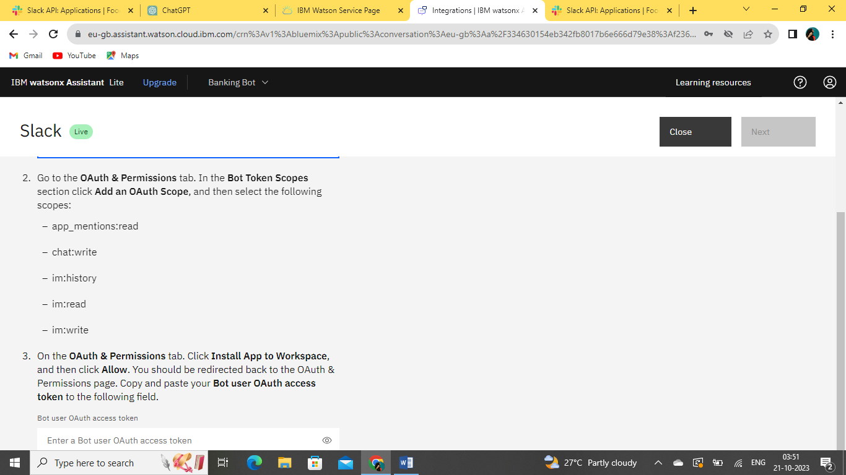

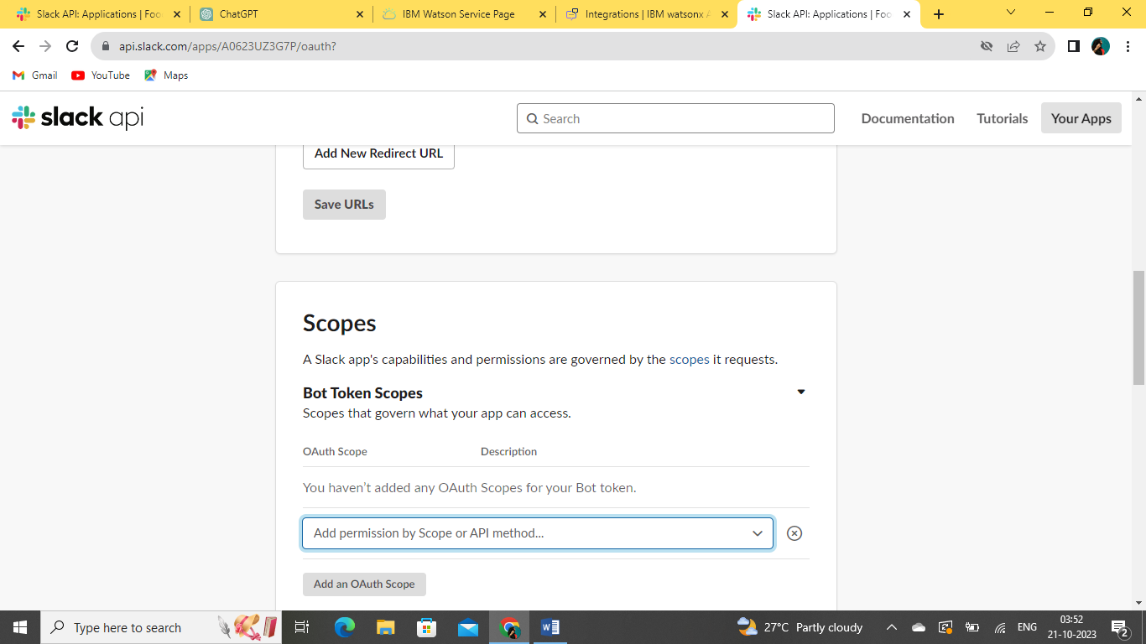

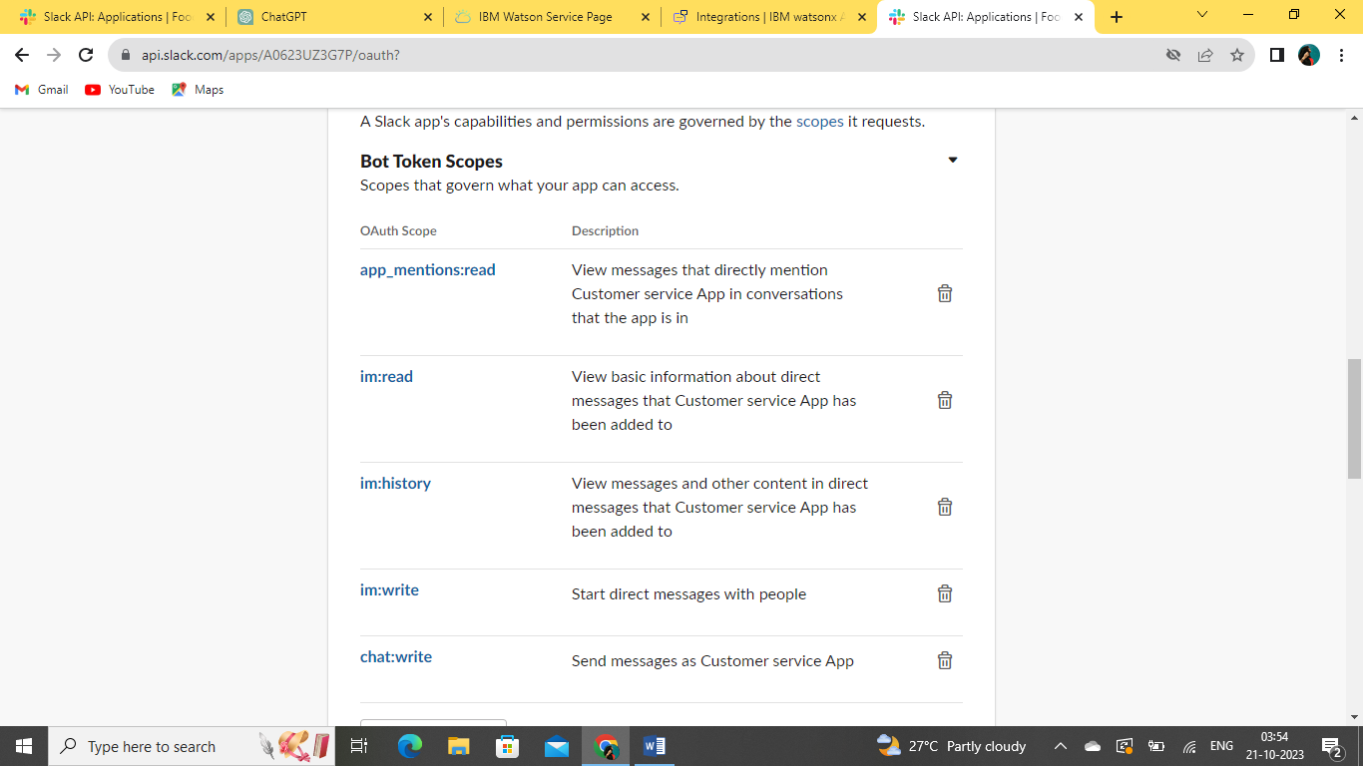

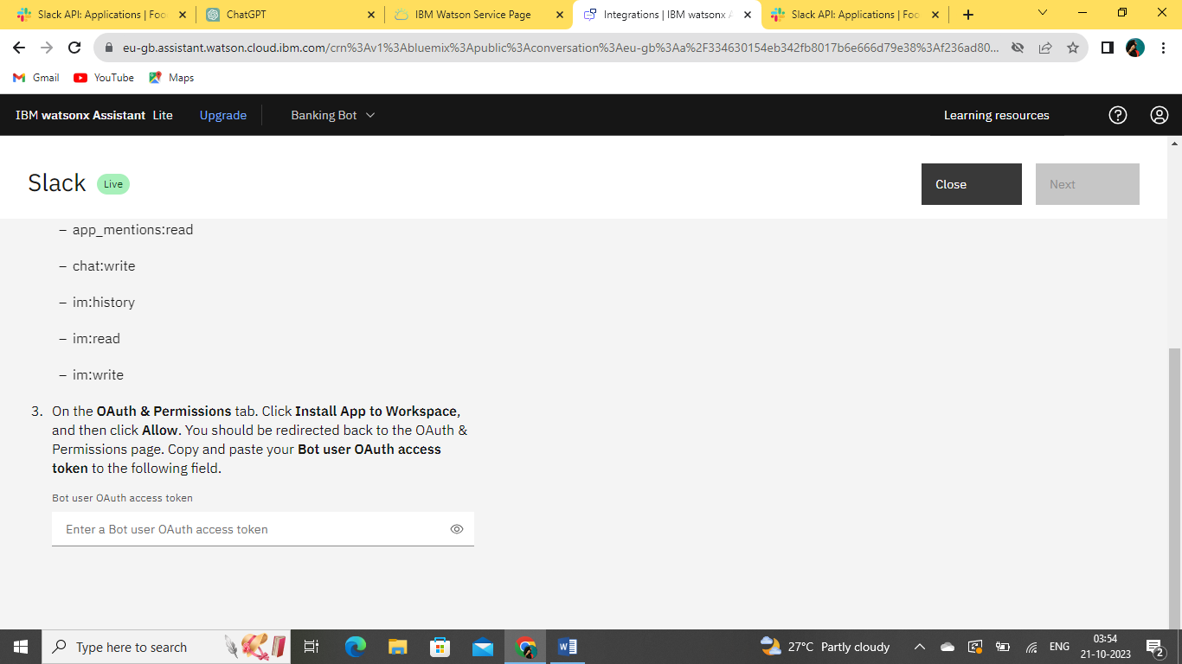

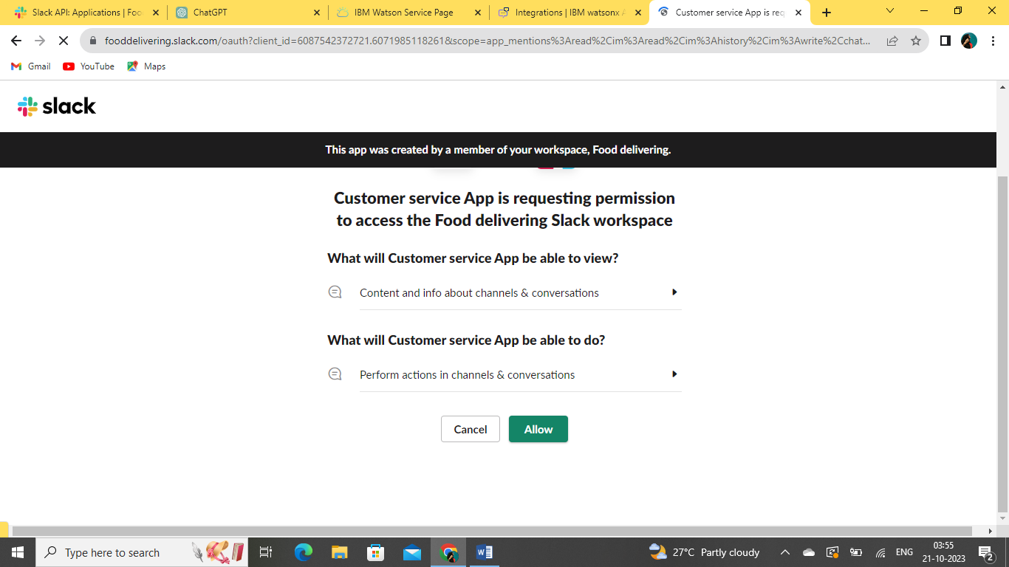

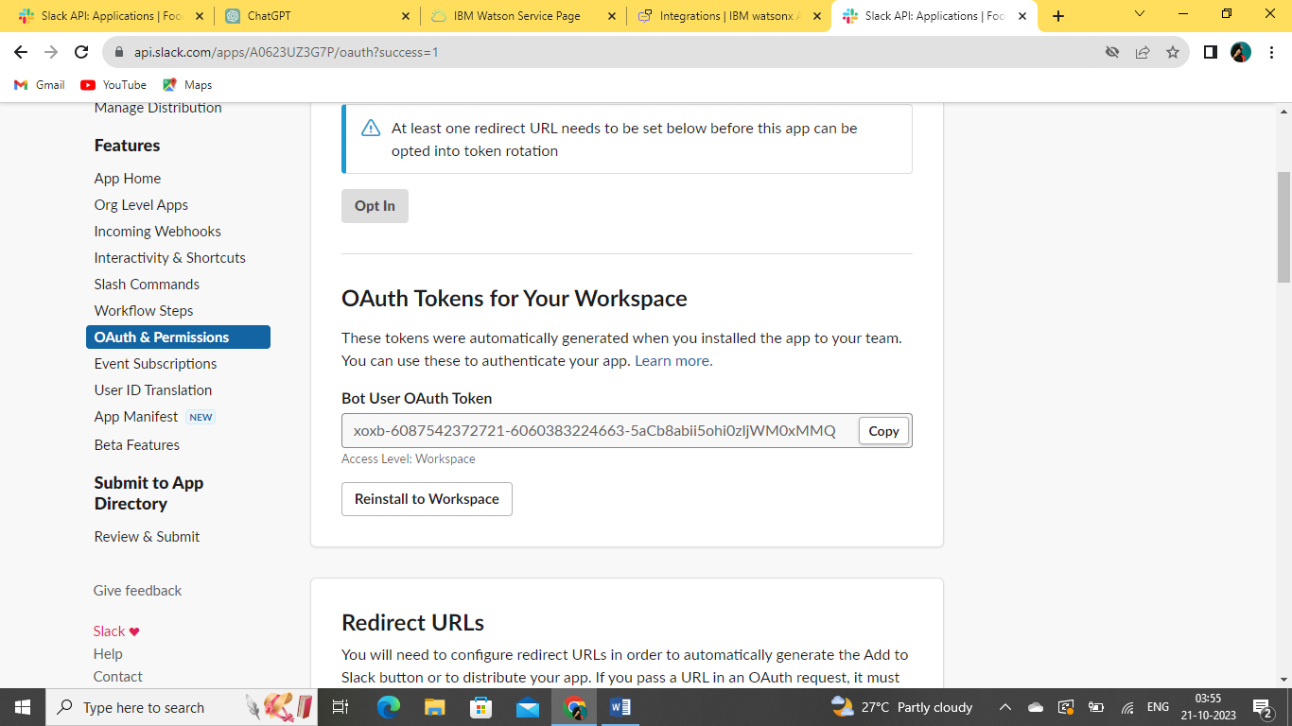

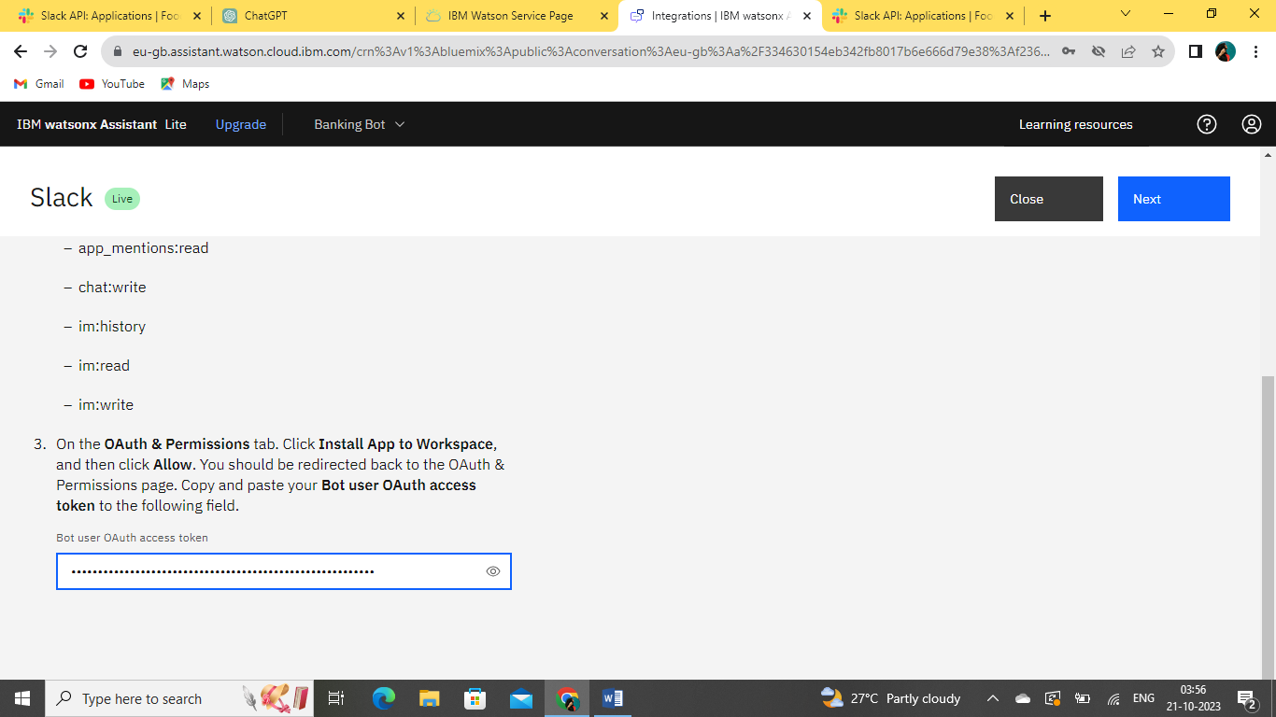

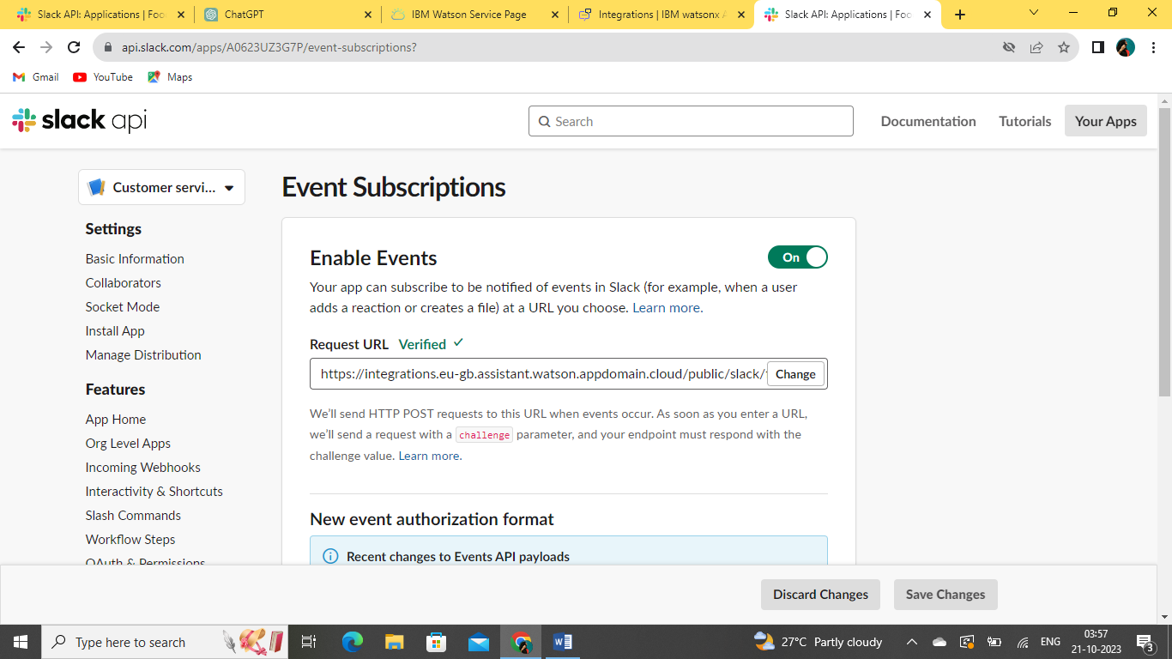

**12.GIVE AN EVENT SUBSCRIPTIONS**

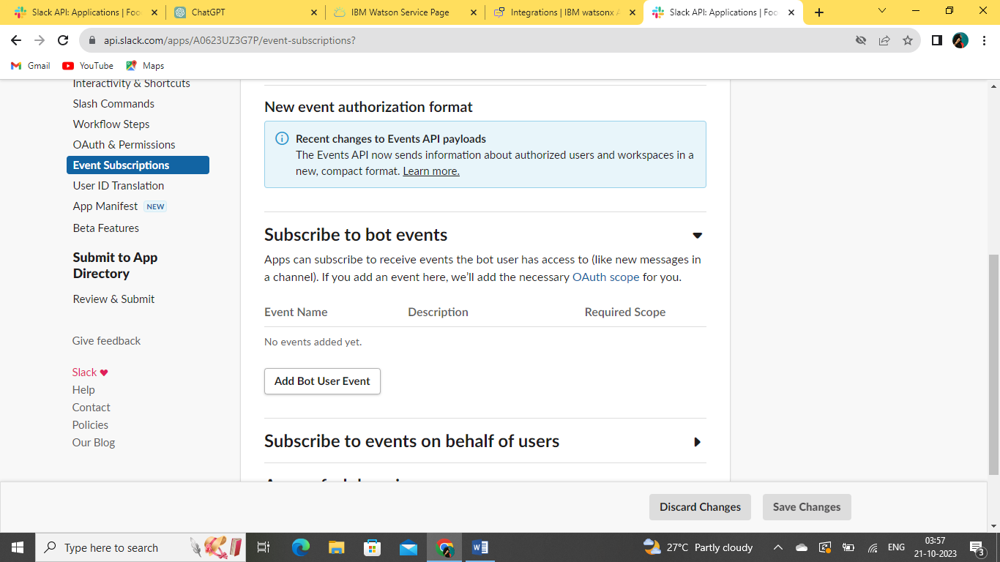

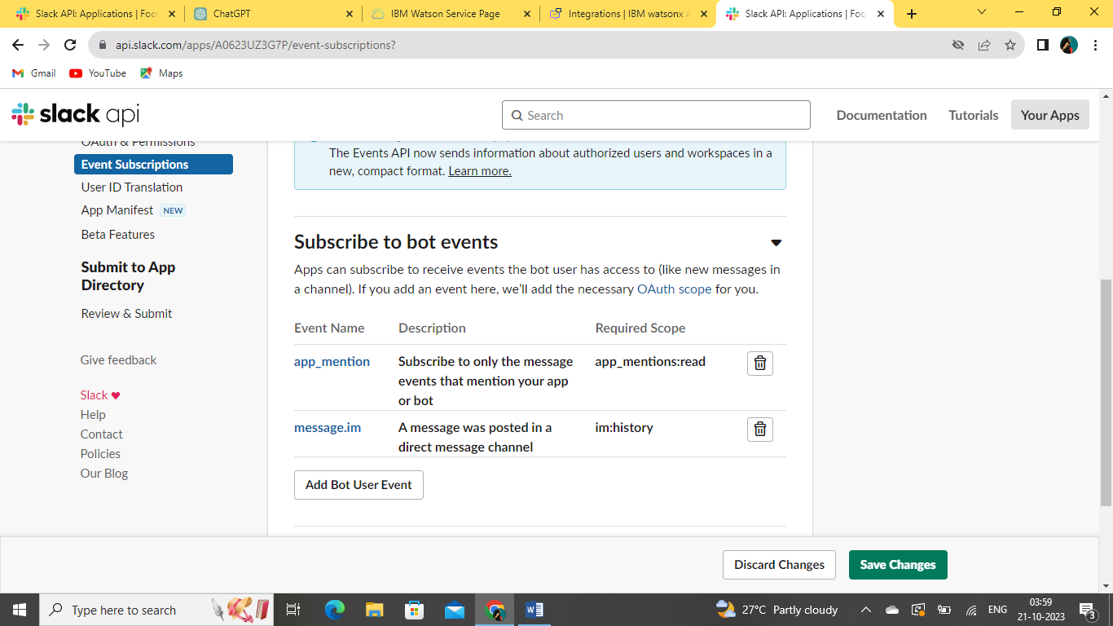

**13.SUCCESSFULLY CREATED A SLACK ACCOUNT**

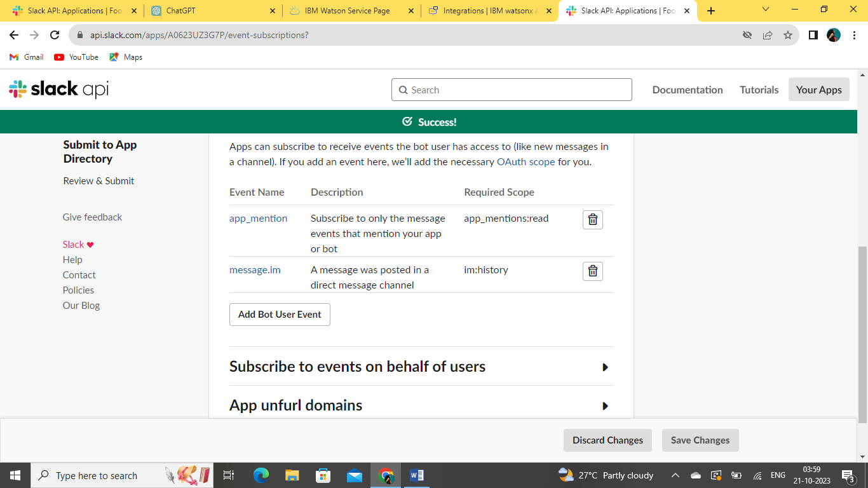

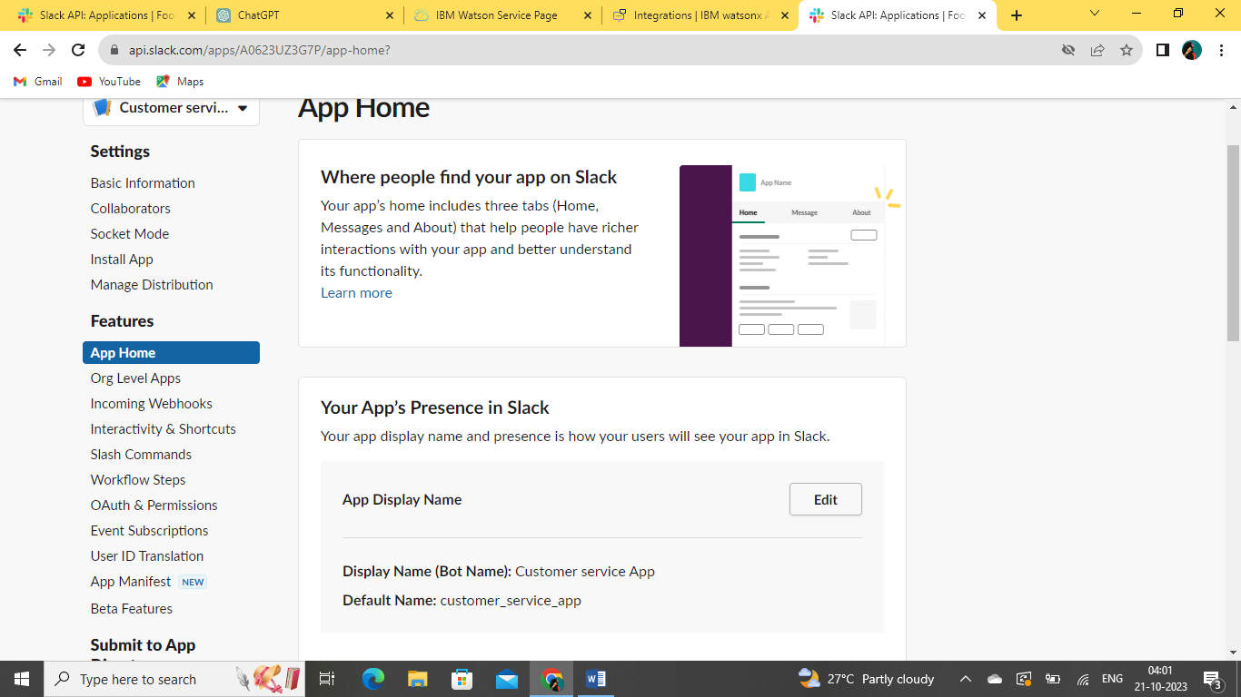

**14.SAVE MY APP DISPLAY NAME HERE:**

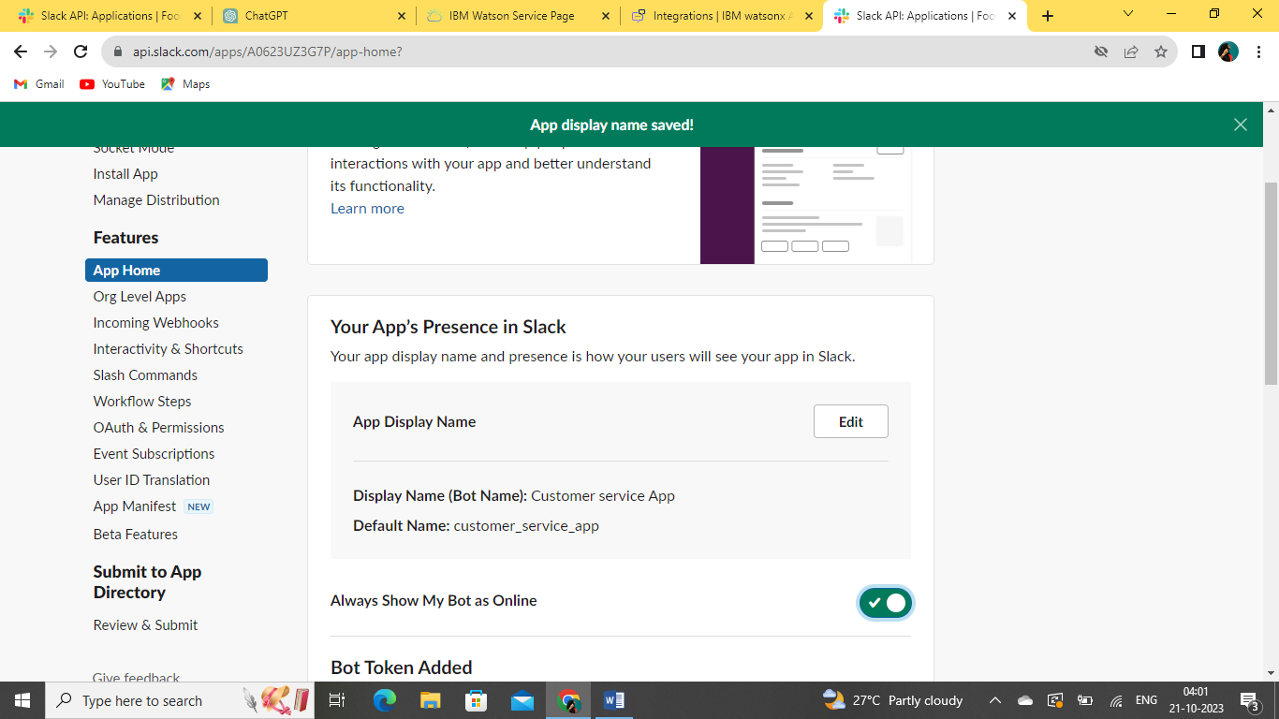

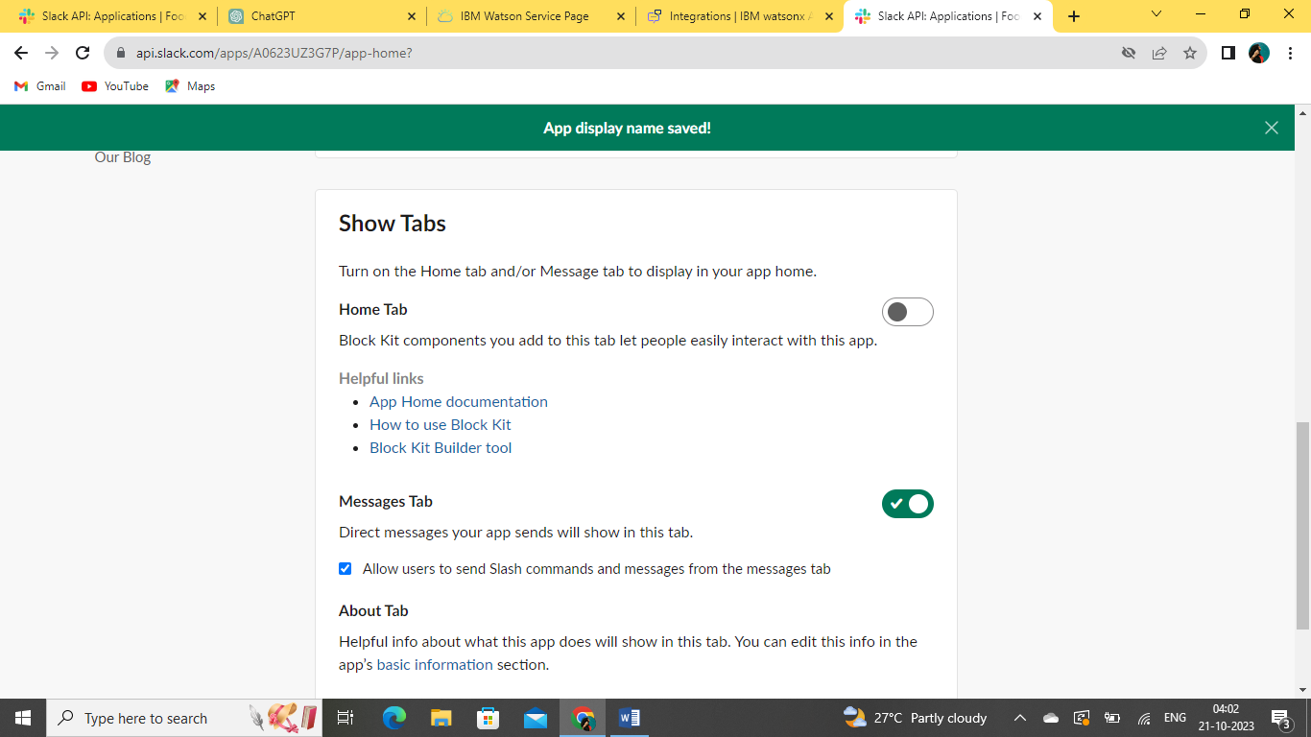

**15.ADD SOME ADDITIONAL FUNCTIONS FOR MY SLACK ACCOUNT LIKE “INTERACTIVITY AND SHORTCUTS”**

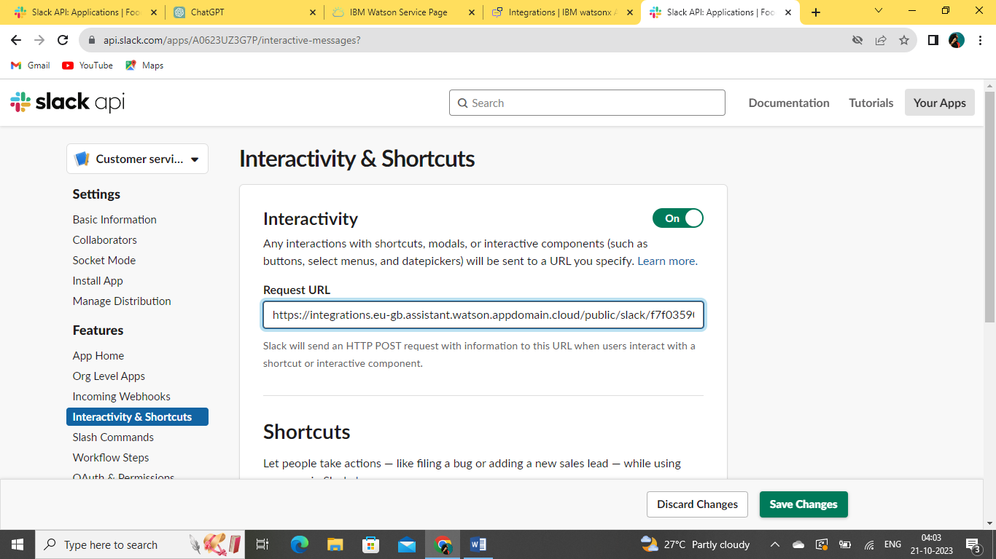

**16.FINALLY, I SUCCESSFULLY CREATED MY SLACK ACCOUNT AND SUCCESSFULLY INTEGRATED WITH MY WATSAON ASSISTANT**

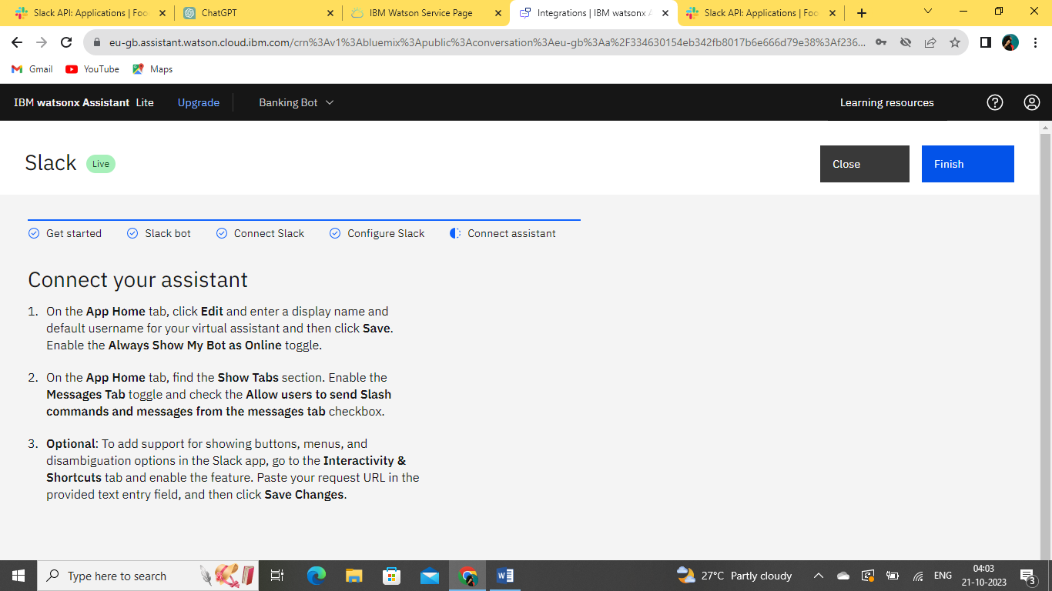

**17.PREVIEW MY SLACK ,IT SUCCESSFULLY RESPONSE MY QUERIES**

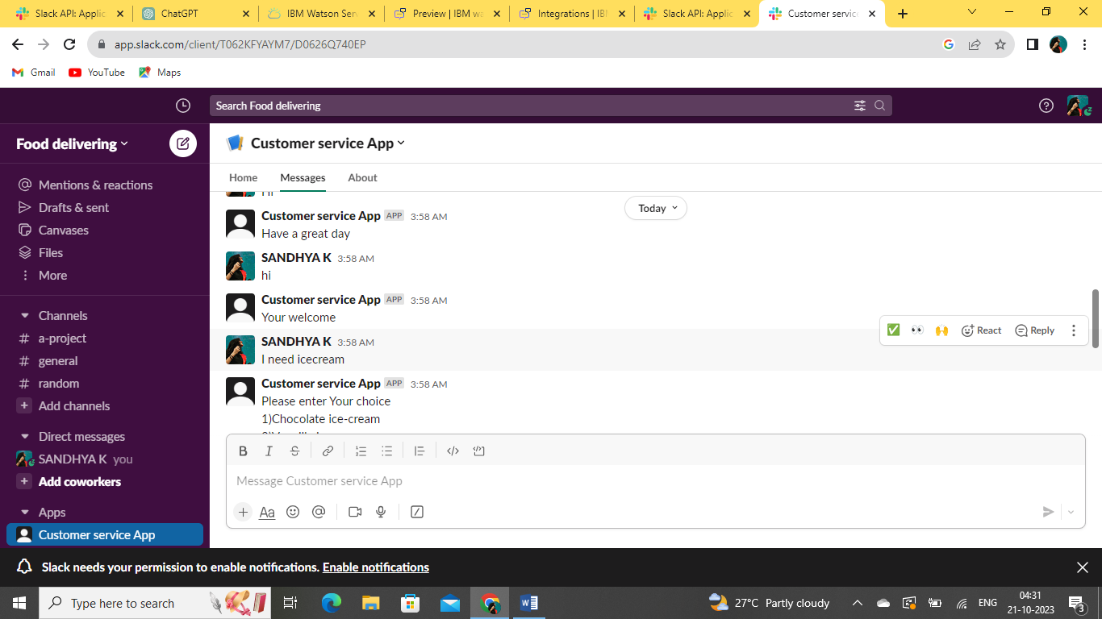

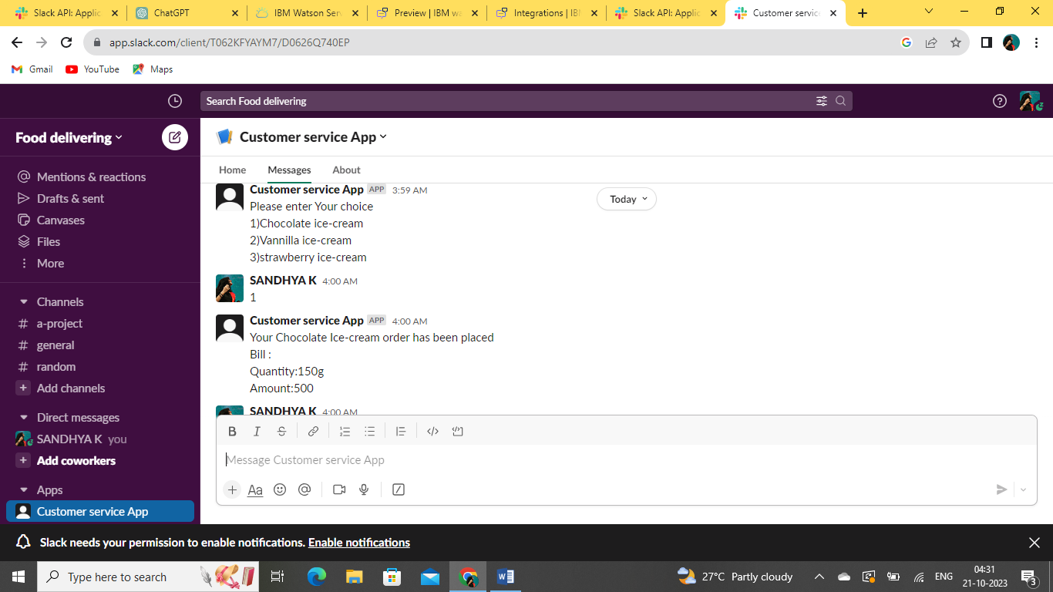

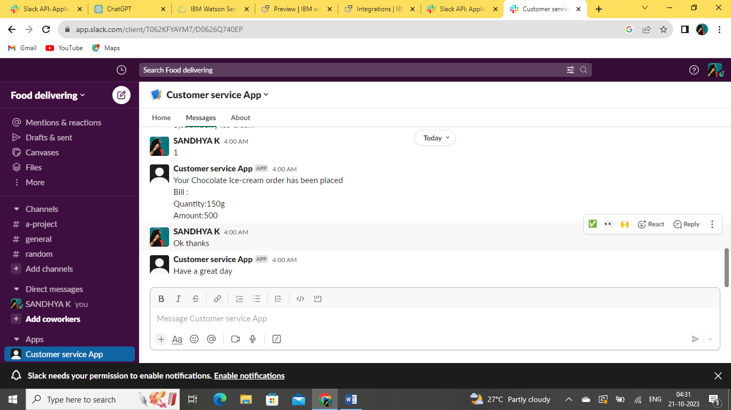

**In that, integrating Slack with IBM Cloud is a useful way to automate tasks and send notifications to Slack channels from your IBM Cloud services or custom applications.**

**By creating a Slack incoming webhook and using IBM Cloud Functions, you can establish this integration easily.**

**FACEBOOK:**

**1.NOW INTEGRATE A FACEBOOK MESSAGER TO MY WATSON ASSISTANT**

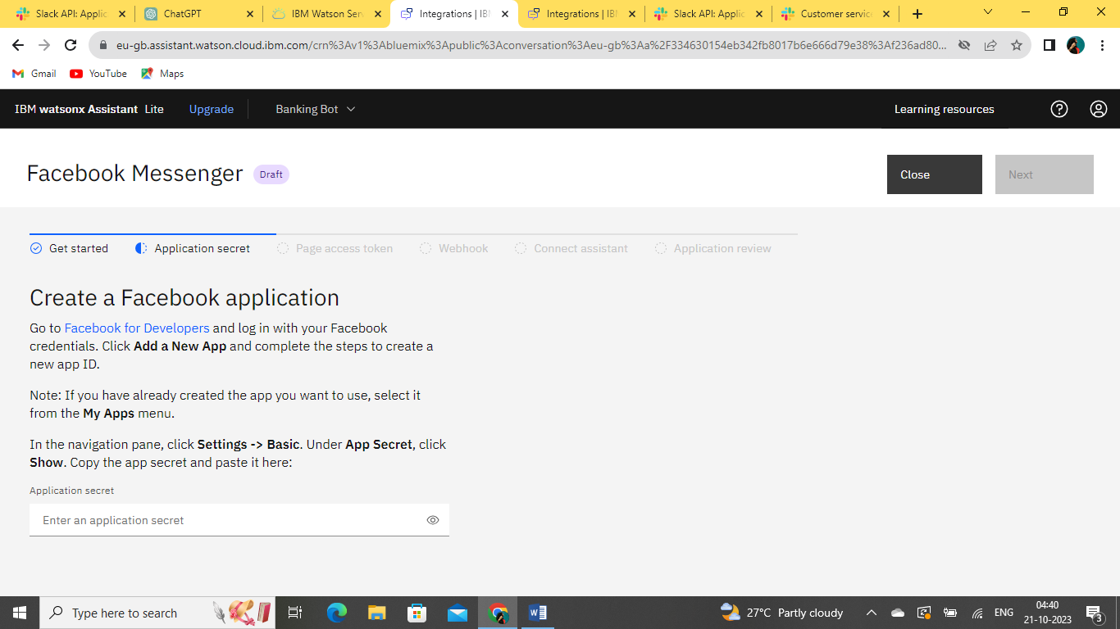

**2.LOGIN TO MY FACEBOOK ACCOUNT**

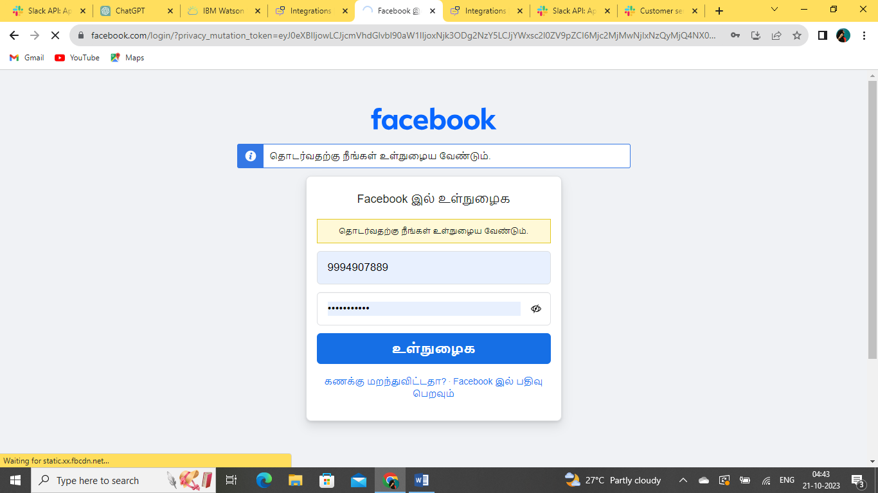

**3.HERE, I CREATE A NEW APP .**

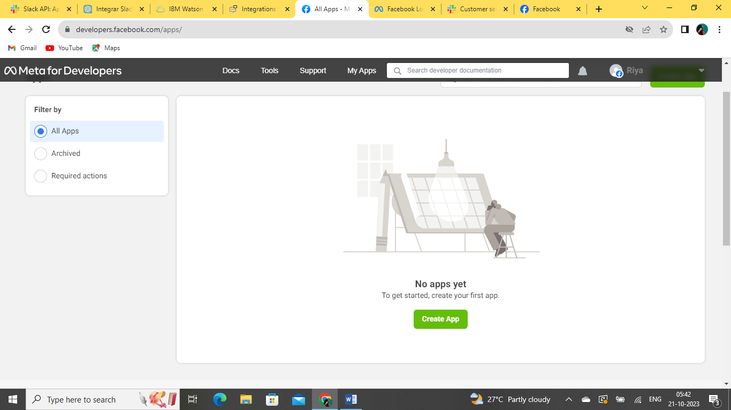

**4.SELECT THE OPTION WHAT DO MY APP TO DO..**

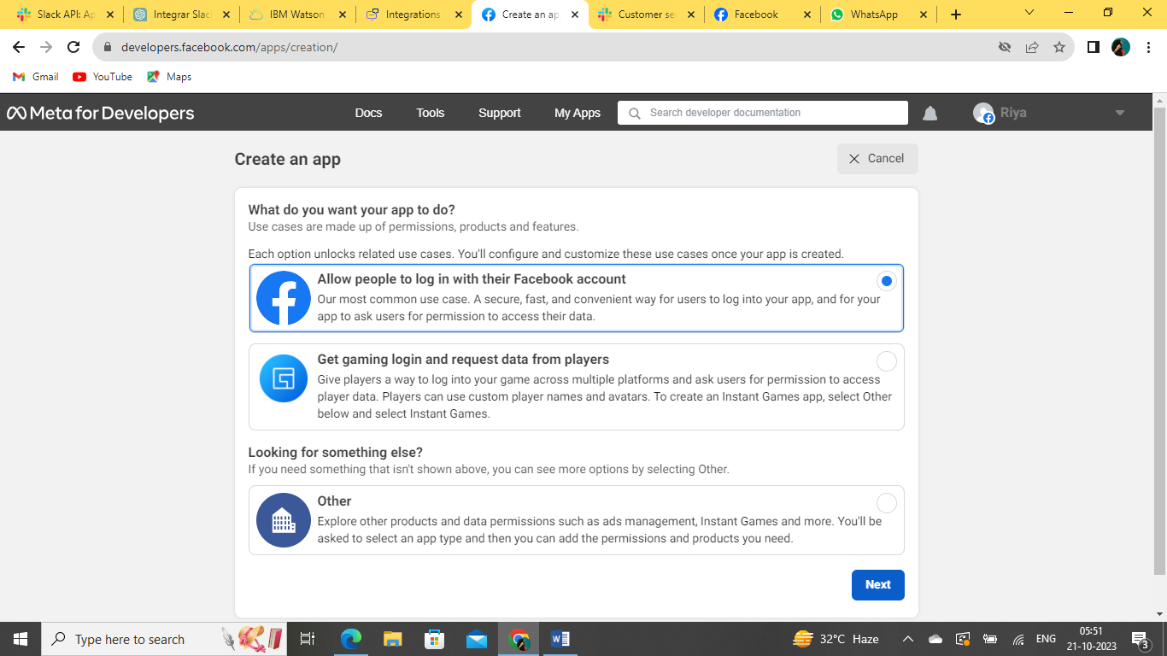

**5.CLICK “CREATE APP”**

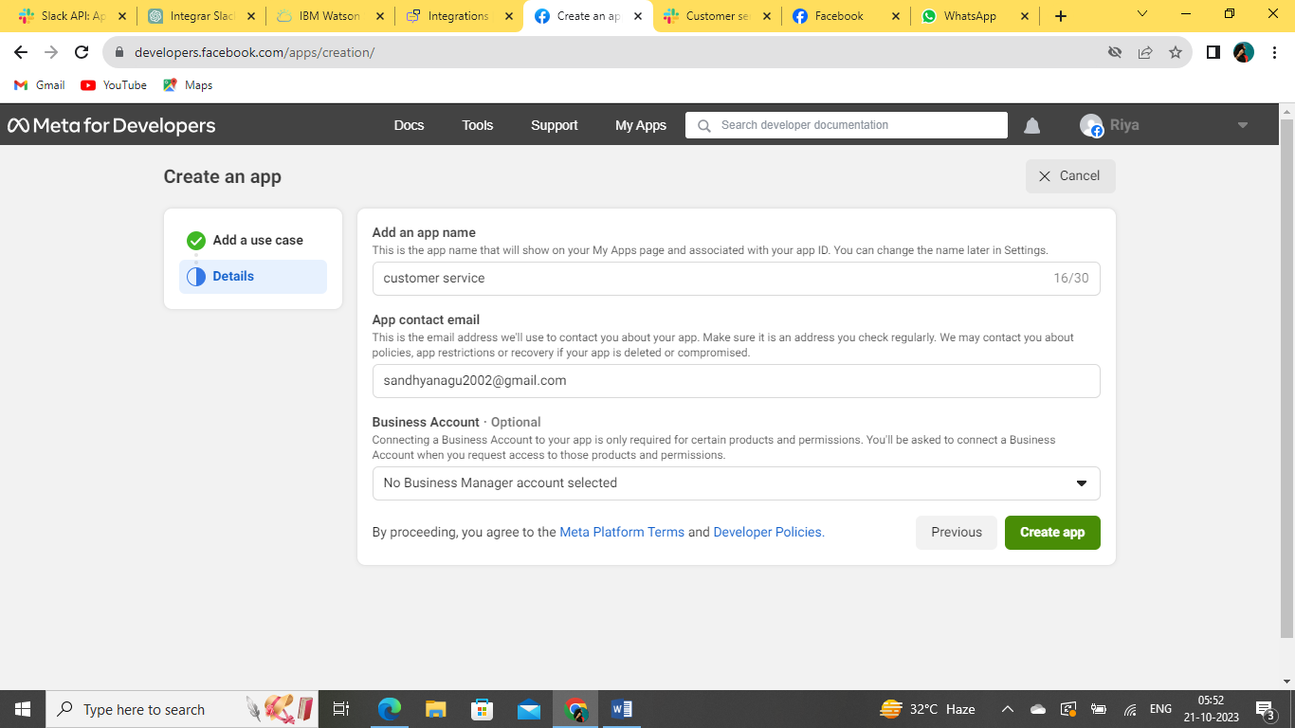

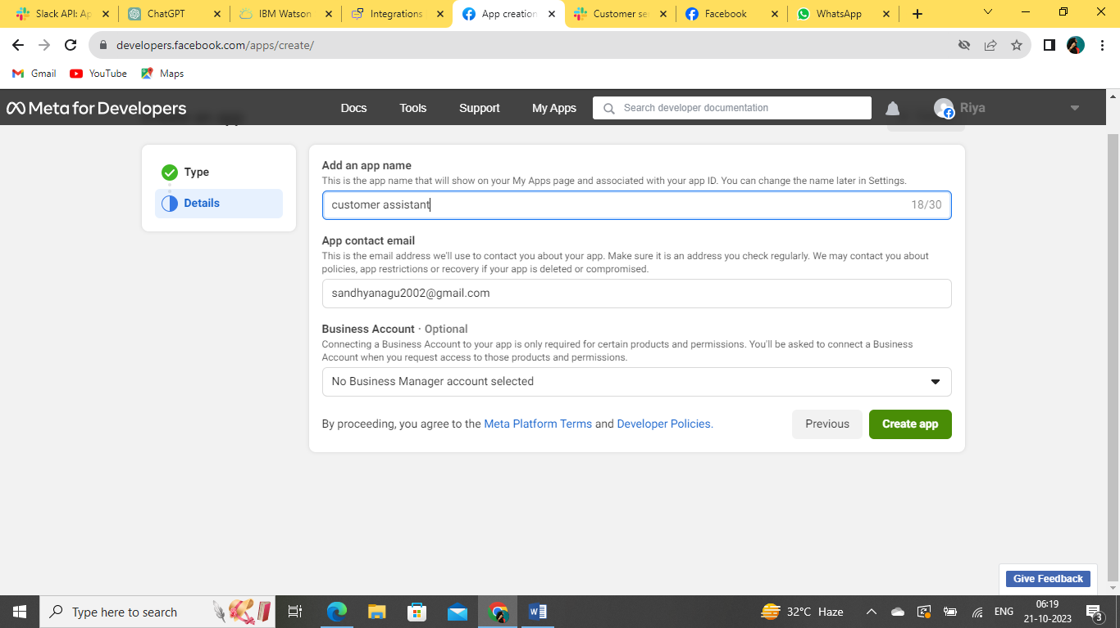

**6.GOT AN APPLICATION SECRET KEY ,PASTE IT INTO MY IBM ACCOUNT**

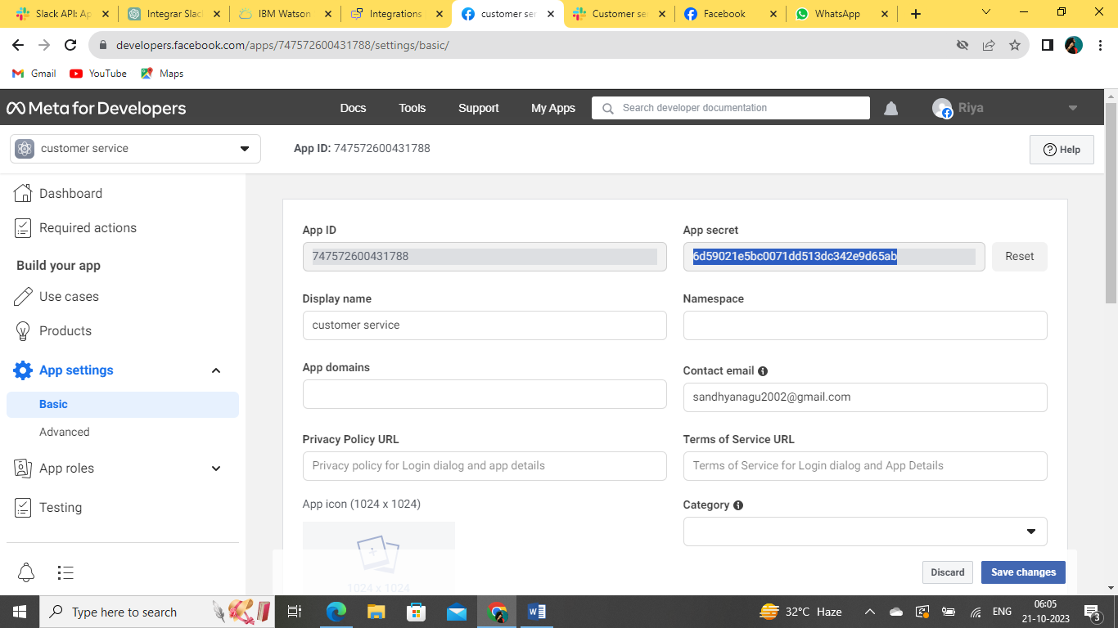

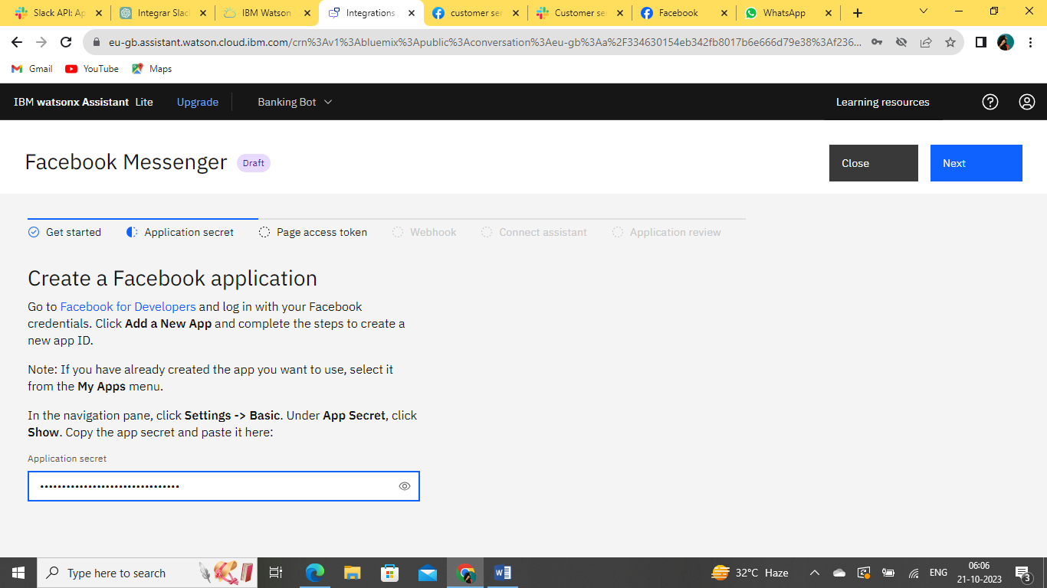

**7.CREATE A PAGE TO BEGIN AND INTGRATED MY CONVERSATION NAMED AS “CUSTOMER ASSITANT TO MY FB ACCOUNT”**

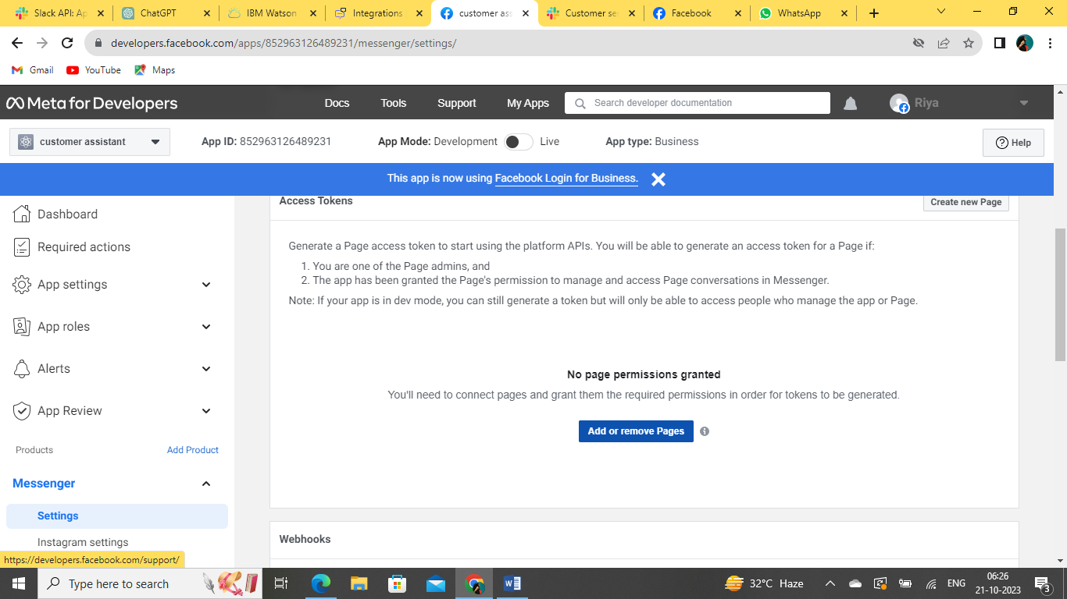

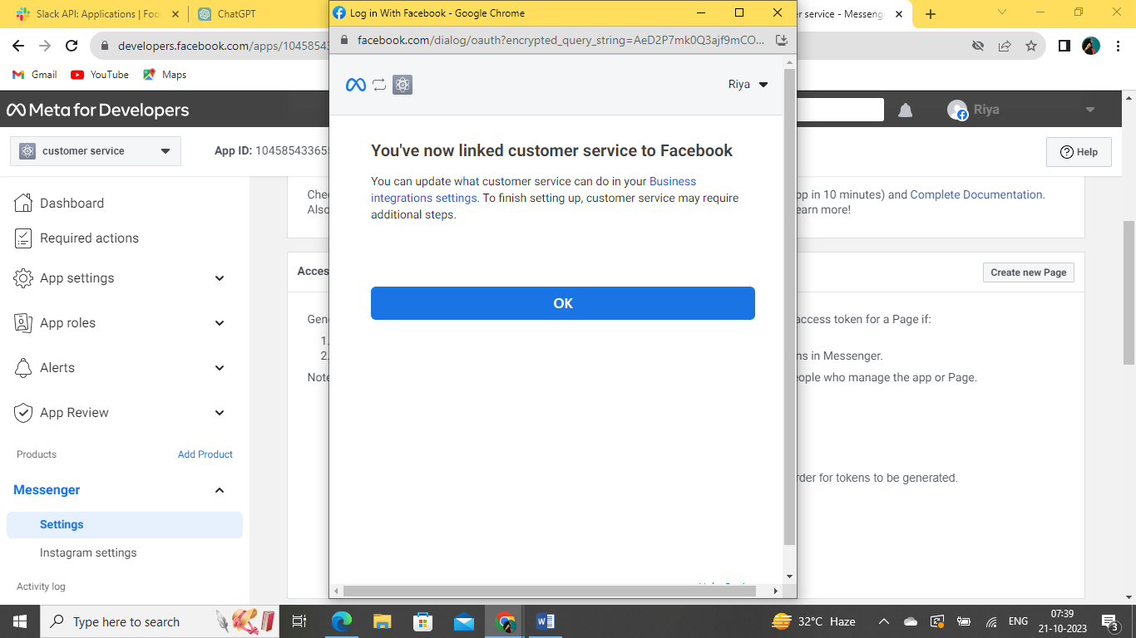

**8.HERE SHOW THE CREATED INTEGRATION CUSTOMER ASSISTANT**

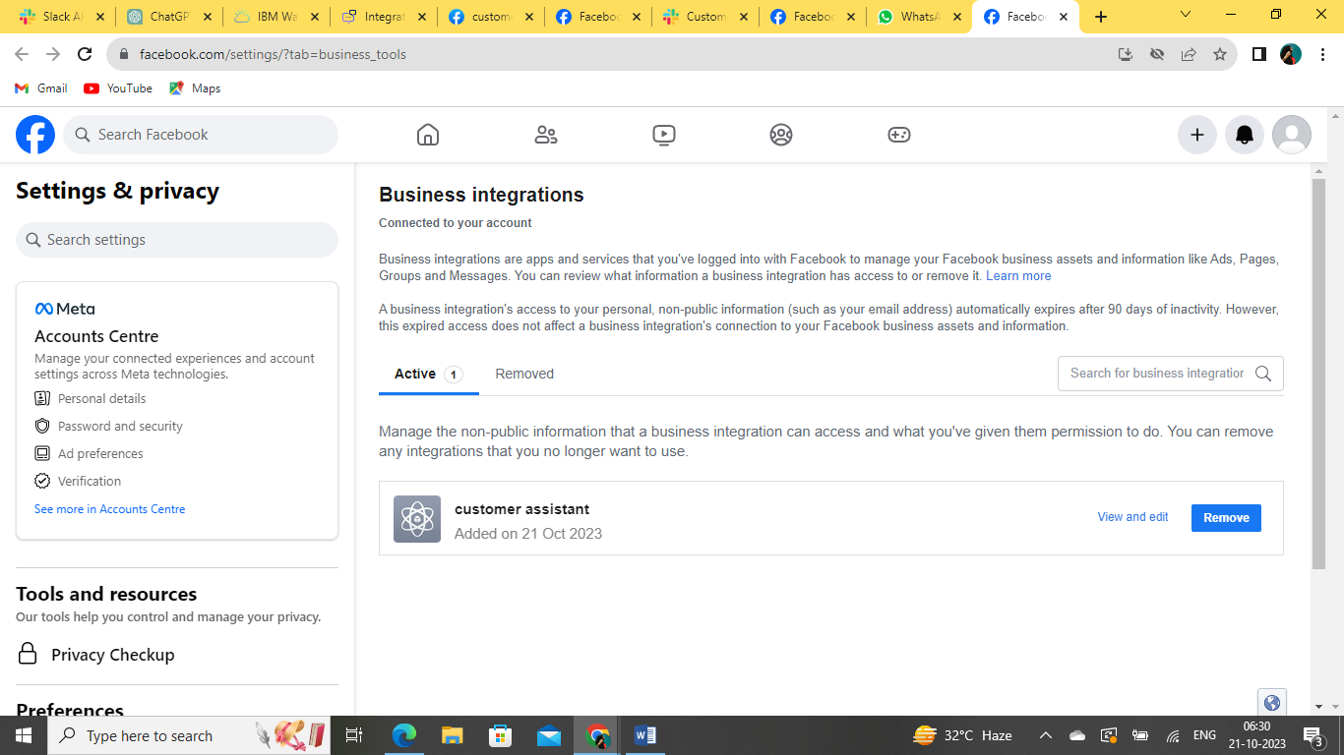

**9.BUSSINESS ACCOUNT PAGE I NAMED IT AS “SANSCO” UNDER THE CATEGORY AS “RESTAURANT”**

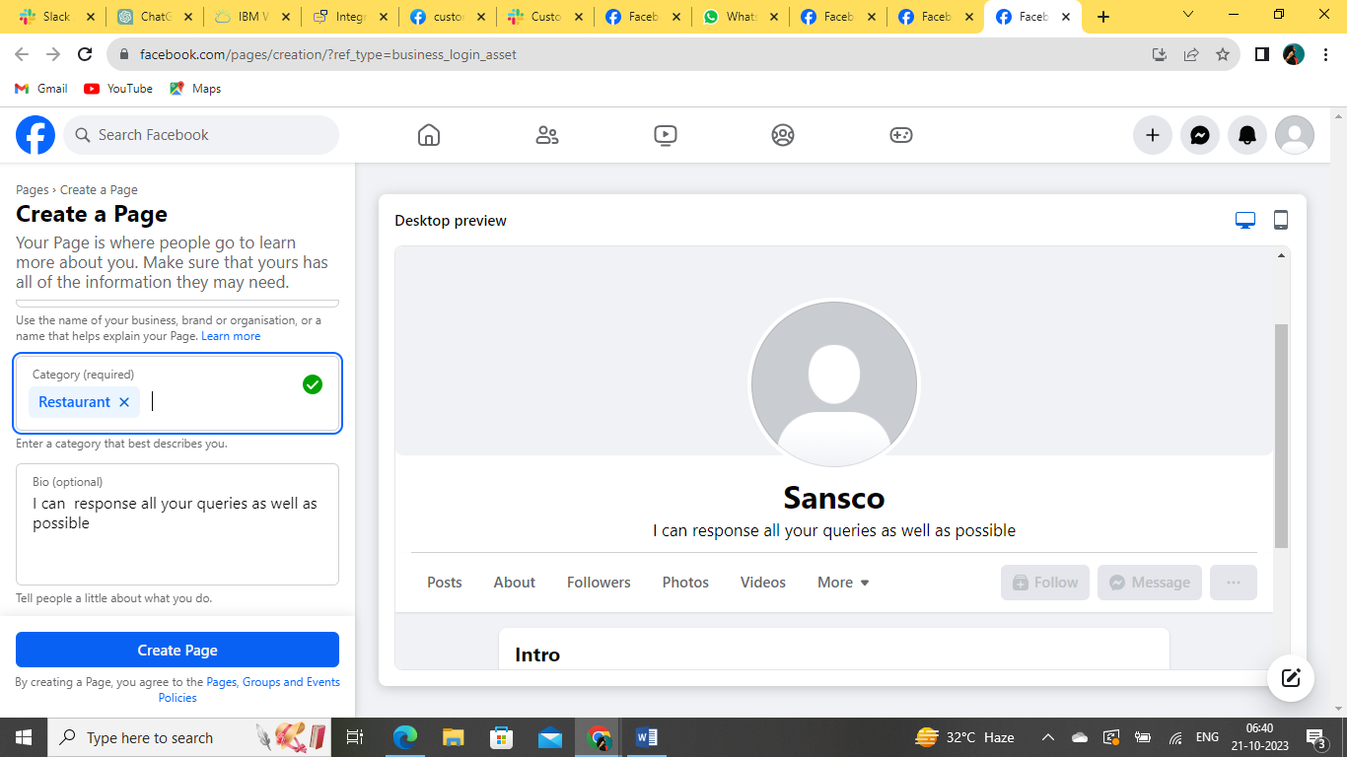

**10.GOT MY ACCESS TOKEN TO ADD IT ON MY CLOUD CHATBOT**

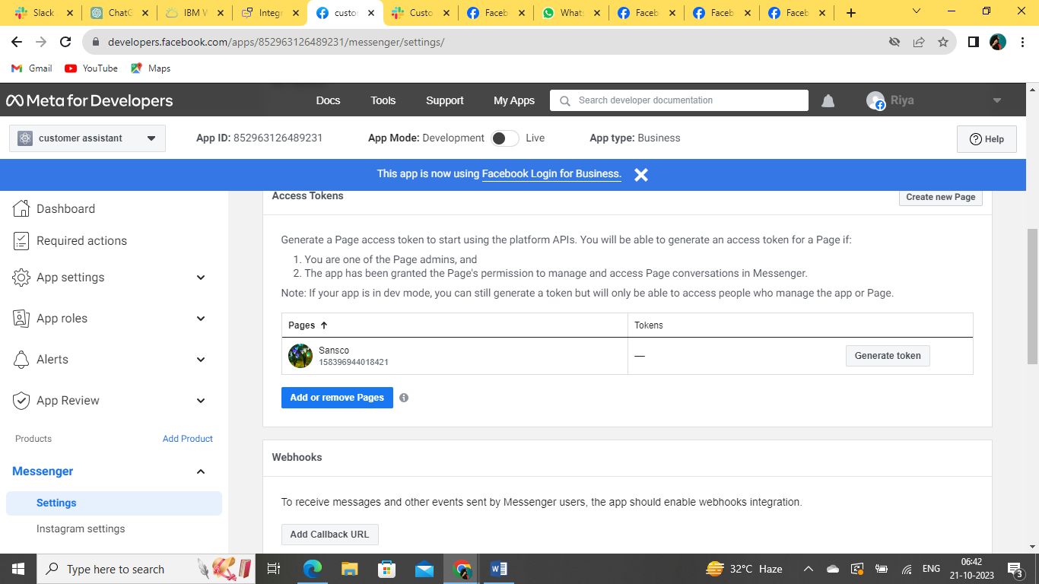

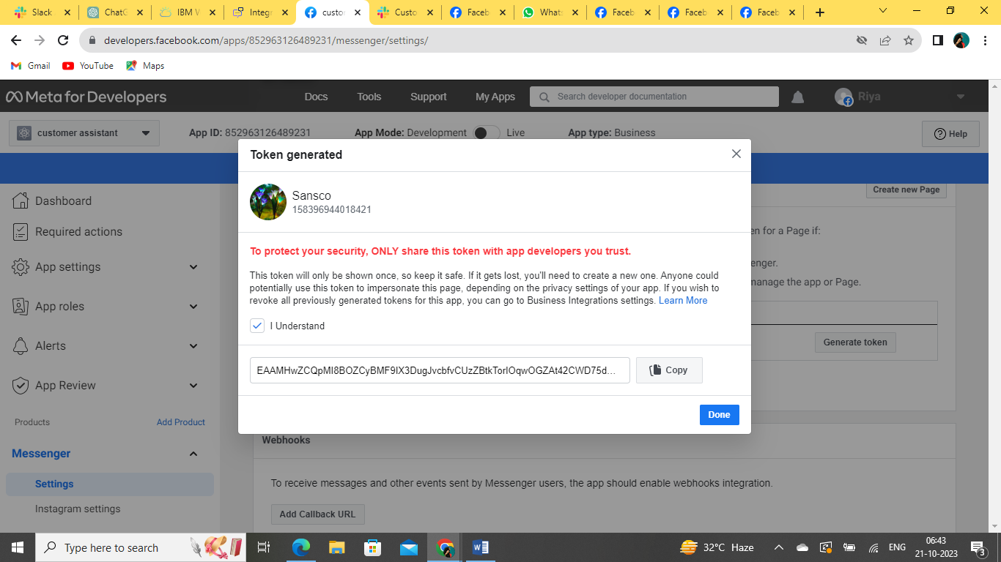

**11.VERIFY MY TOKEN TO THE WEBOOK URL**

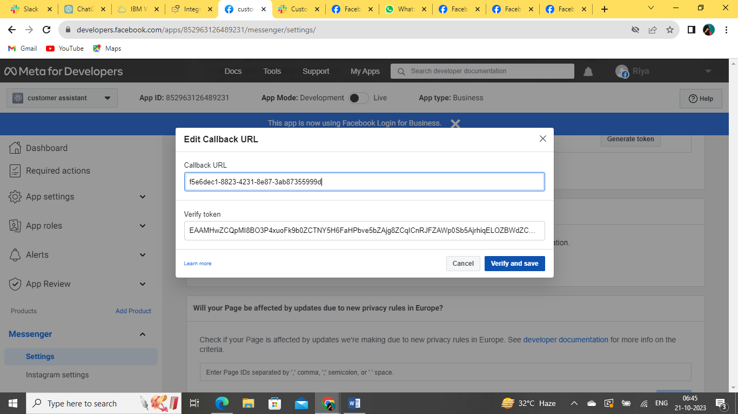

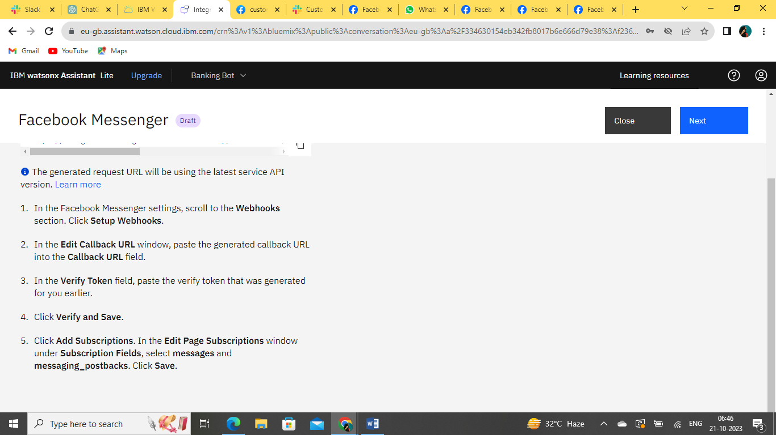

**12.ADD A NEEDED SUBSCRIPTION TO THE WEBHOOK “messages” and “messaging_postbacks”**

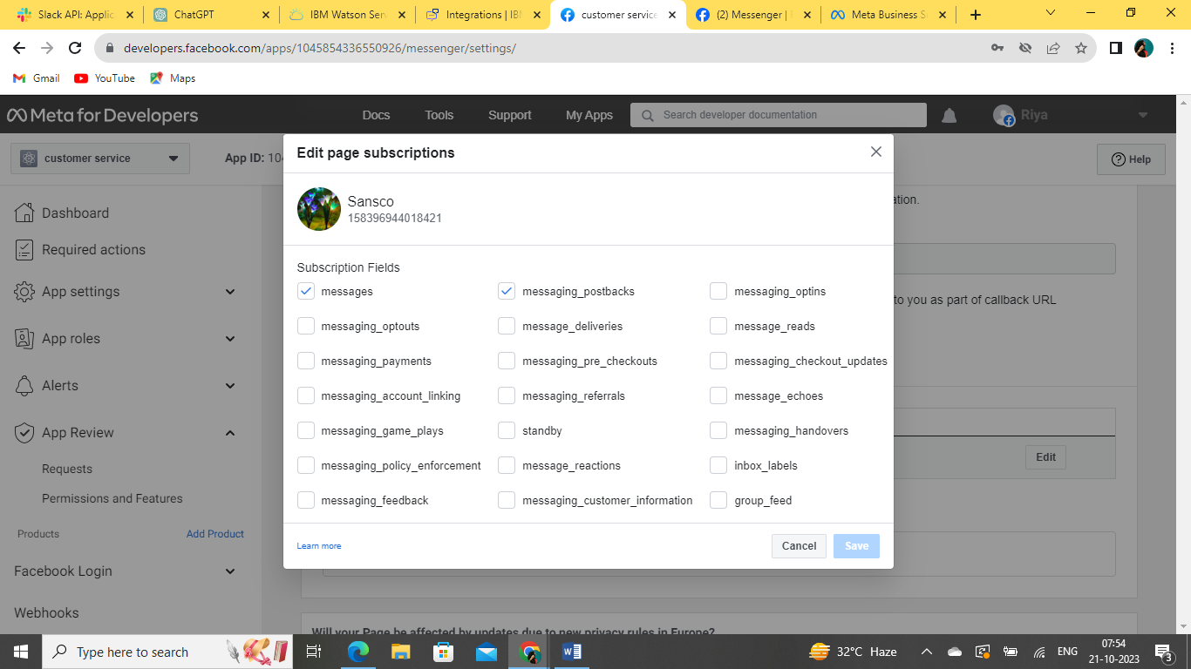

**13.Here I successfully added a messager and webhook**

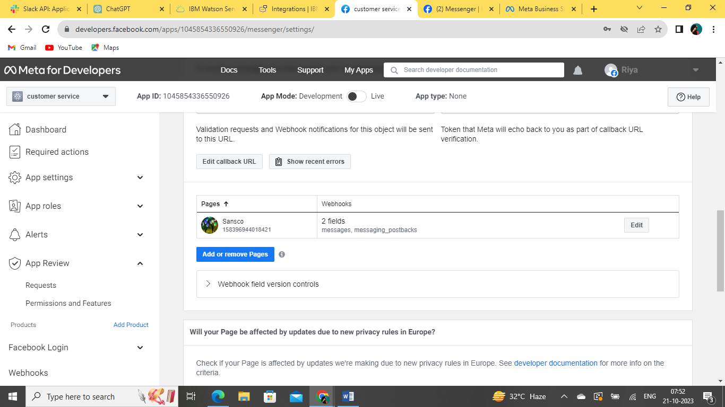

**14.IN MY FB ACCOUNT I SEARCH A PAGE “SANSCO” THEN I START MY CONVERSATION…**

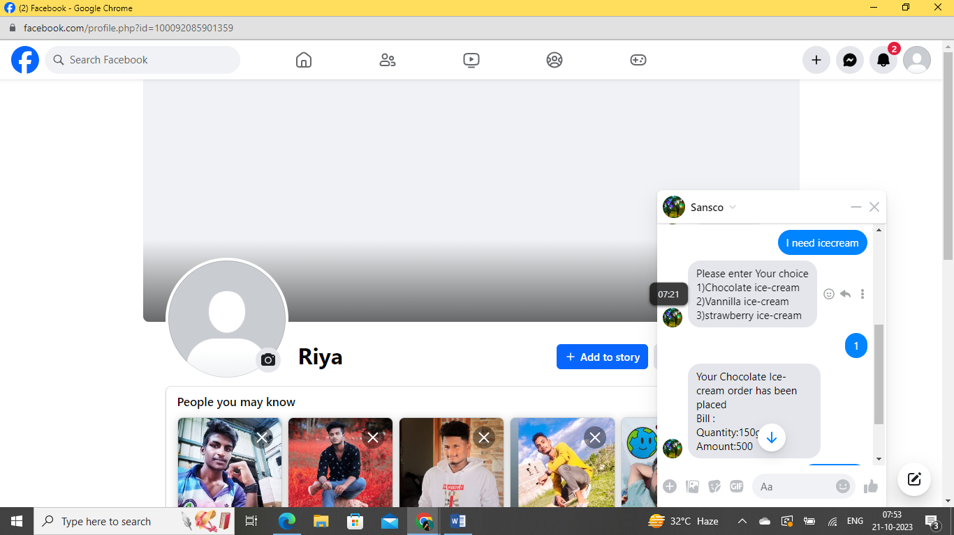

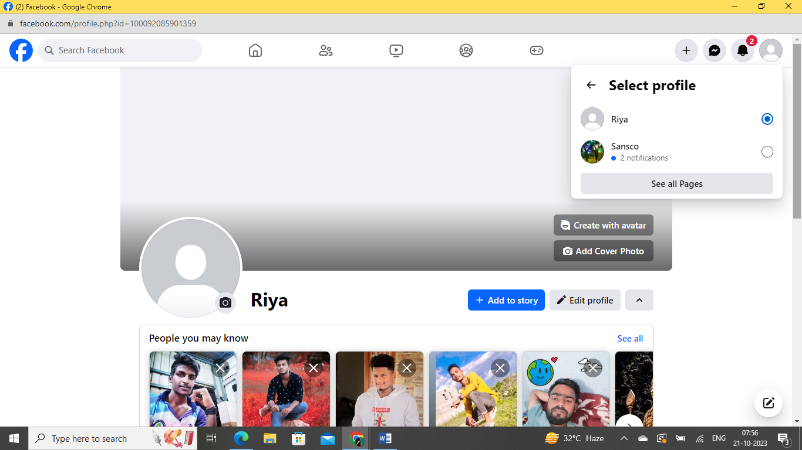

**15.SANSO ASSISTANT PAGE THAT PERFECTLY GIVE A RESPONSE TO MY QURIES ..**

**16.FINALLY I SUCCESSFULLY INTEGRATED A FACEBOOK MESSAGER..**

**PREVIEW MY ASSISTANT SUCCESSFULLY..**

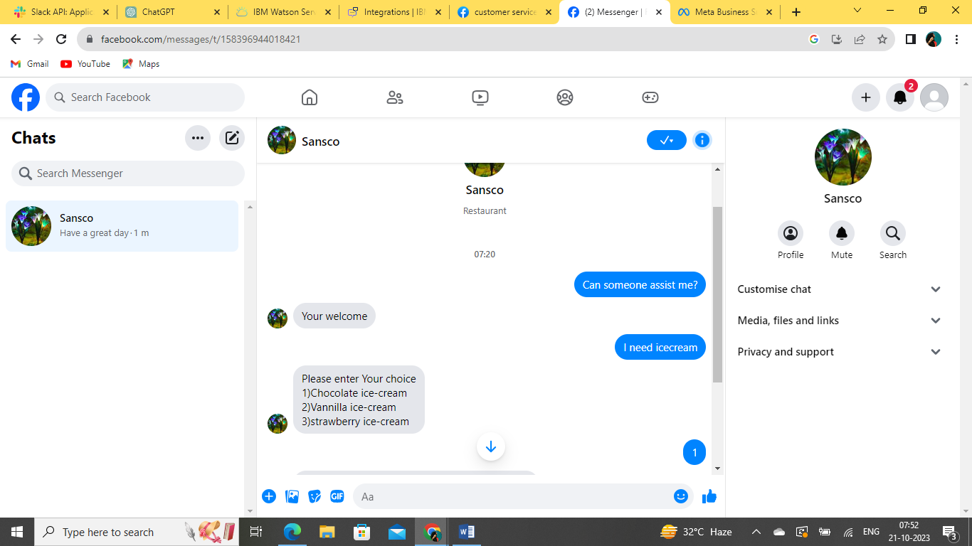

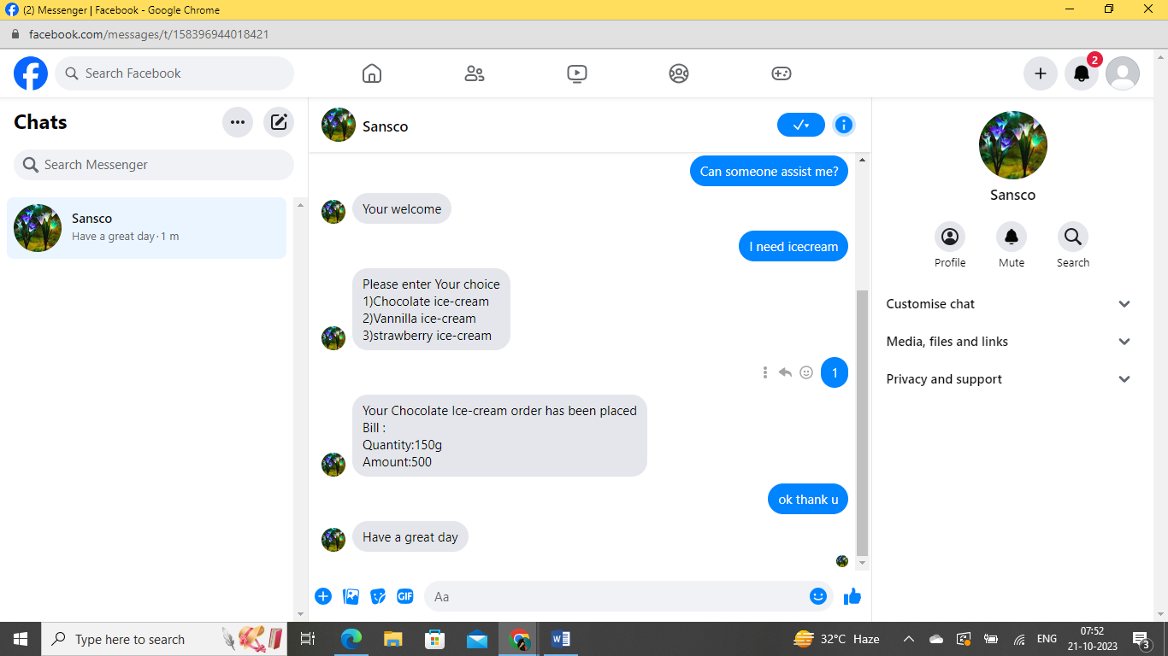

Integrating Facebook with IBM Cloud typically involves using Facebook's API to interact with Facebook's platform and services. You can integrate Facebook features like authentication, sharing, or posting content in your IBM Cloud application. Here's a general outline of the steps you can follow to integrate Facebook with IBM Cloud: